SCORE ME: Self-assessment of Capacity in Organization’s Response to M&E
 |  | Elements of Knowledge and Practice of Individuals who is  Responsible for M&E within Organization / Unit |  |  | If YES Check √ |  | Evidence or Example Available?  Please Specify
 |  | AA | M & E Professional Practice
 | 1. I have sufficient medically-related knowledge of my organization’s health programs
 | If YES, provide evidence or example
 | 2. I have sufficient knowledge to support monitoring of my organization’s health programs
 | If YES, provide evidence or example
 | 3. I have sufficient knowledge to support evaluation of my organization’s health programs
 | If YES, provide evidence or example
4. I have sufficient knowledge and practical skills to meet my organization’s needs for
data collection in our health programs
 | If YES, provide evidence or example
5. I have sufficient knowledge and practical skills to meet my organization’s needs for
data quality assessment in our health programs
 | If YES, provide evidence or example
6. I have sufficient knowledge and practical skills to meet my organization’s needs for
data compilation and storage in our health programs
 | If YES, provide evidence or example
7. I have sufficient knowledge and practical skills to meet my organization’s needs for
data analysis and reporting in our health programs
 | If YES, provide evidence or example
8. I have sufficient knowledge and practical skills to meet my organization’s needs for
data use in our health programs
 | If YES, provide evidence or example
 | Total Number of Check Marks √ |  |  |  |  | 0 or 1 |  | 2 or 3 | 4 | 5 or 6 | 7 or 8
 | 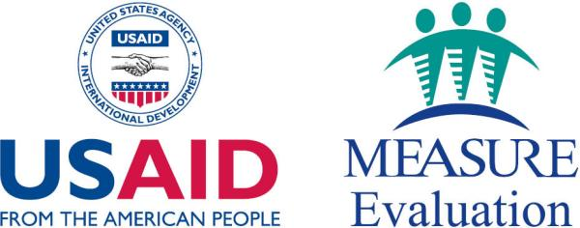 |  |  |  |  | 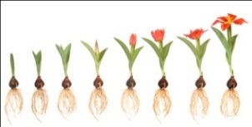 |  | 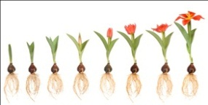 | 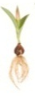 | 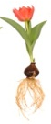 | 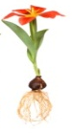
 |  |  |  |  |  | 1 |  | 2 | 3 | 4 | 5

SCORE ME: Self-assessment of Capacity in Organization’s Response to M&E
Elements of Knowledge and Practice of Individuals who is  Responsible for M&E within Organization / Unit |  |  | If YES Check √ | Evidence or Example Available?  Please Specify
BB | M & E Staff Management and Development; Interpersonal Competence |  | If YES Check √
1. I have sufficient knowledge and practical skills to meet my organization’s needs for management and coordination of M&E work processes
If YES, provide evidence or example
2. I have sufficient knowledge and practical skills to meet my organization’s needs for management and professional development of M&E staff
If YES, provide evidence or example
3. I have sufficient knowledge and practical skills to meet my organization’s needs for training and mentoring of M&E staff
If YES, provide evidence or example
4. I have sufficient knowledge and practical skills to meet my organization’s needs for facilitating work coordination among M&E staff
If YES, provide evidence or example
5. I have sufficient knowledge and practical skills to meet my organization’s needs for seeking and gaining consensus with organization’s staff
If YES, provide evidence or example
6. I have sufficient knowledge and practical skills to meet my organization’s needs for cultivating and sustaining relationships with current & prospective donors
If YES, provide evidence or example
7. I have sufficient knowledge and practical skills to meet my organization’s needs for advocating on behalf of organization to stakeholders & outside audiences
If YES, provide evidence or example
8. I have sufficient knowledge and practical skills to meet my organization’s needs for effectively delivering oral & written presentations on behalf of organization
If YES, provide evidence or example
Total Number of Check Marks √ |  |  |  | 0 or 1 | 2 or 3 | 4 or 5 | 6 or 7 | 8
 |  |  |  | 1 | 2 | 3 | 4 | 5

SCORE ME: Self-assessment of Capacity in Organization’s Response to M&E
Elements of Knowledge and Practice of Individuals who is  Responsible for M&E within Organization / Unit |  | If YES Check √ | Evidence or Example Available?  Please Specify
CC | Reading Internal and External Environments to Support M&E of Health Programs | If YES Check √
- I have sufficient knowledge and practical skills to meet my organization’s needs for interpreting on an ongoing basis trend patterns from analysis of monitoring data of the organization’s health programs
If YES, provide evidence or example
- I have sufficient knowledge and practical skills to meet my organization’s needs for translating the interpretation of trend patterns into revised approaches for improving the performance of the organization’s health programs
If YES, provide evidence or example
- I have sufficient knowledge and practical skills to meet my organization’s needs for interpreting the findings and observations from an evaluation of the organization’s health programs into revised approaches for improving the performance of the organization’s health programs
If YES, provide evidence or example
4. I have sufficient knowledge and practical skills in matters related to addressing situational contexts (political, economic, social, religious, and cultural) in which the organization’s health programs operate
If YES, provide evidence or example
5. I have sufficient knowledge and practical skills in matters related to addressing relationships among international, governmental, and non-governmental organizations working in sectors relevant to health programming
If YES, provide evidence or example
6. I have sufficient knowledge and practical skills in matters related to leadership and leadership building to support efforts in improving the performance of the organization’s health programs
If YES, provide evidence or example
Total Number of Check Marks √ |  |  | 0 | 1 | 2 or 3 | 4 or 5 | 6
 |  |  |  |  |  | 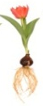 | 
 |  |  | 1 | 2 | 3 | 4 | 5

