



Acknowledgments
We thank the United States Agency for International Development (USAID) and the United States President’s Emergency Plan for AIDS Relief (PEPFAR) for their support of this publication.
This document was prepared to accompany “Using DHIS2 Software to Track Prevention of Mother-to-Child Transmission of HIV: Guidance (Version 2)”, developed by Cristina de la Torre, Samuel Johnson, and Allison Schmale, at https://www.measureevaluation.org/resources/pmtct-tracker.

We would also like to thank Cindy Young-Turner, of ICF, for editing this report and the knowledge management team at MEASURE Evaluation, University of North Carolina at Chapel Hill, for editing, design, and production services.

Suggested citation: Scott, F., Schmale, A., Moonzwe Davis, L., Johnson, S., & de la Torre, C. (2019). Using DHIS2 Software to Track Prevention of Mother-to-Child Transmission of HIV: User Manual for the DHIS2 PMTCT Tracker. Chapel Hill, NC, USA: MEASURE Evaluation, University of North Carolina at Chapel Hill.

Contents
Acknowledgments v
Abbreviations viii
1. Introduction to this Manual 1
2. PMTCT Tracker Concepts 2
2.1 Patient Tracking 2
2.2 The PMTCT Tracker Pathway of Care 2
2.3 Confidentiality and Data Protection 4
3. Accessing and Navigating the PMTCT Tracker 5
3.1 Levels of Access to the PMTCT Tracker 5
3.2 How to Open the PMTCT Tracker 6
3.3 How to Log into and out of the PMTCT Tracker 6
3.4 Navigating the PMTCT Tracker 7
3.4.1 Navigating Modules 7
3.4.2 Understanding the Layout of the Patient Dashboard 8
3.5 How to Manage Your Own User Account 10
4. Data Capture and Review: General Principles 11
4.1 How Data Are Saved 12
4.2 Temporary Interruptions to the Internet 12
4.3 Validation Rules, Warnings, and Errors 13
4.4 Audit Trails 14
5. Data Capture and Review: Mother’s PMTCT Program 15
5.1 How to Search for an Existing Patient 15
5.2 How to Register and Enroll a New Patient 16
5.3 How to Enroll a Mother if Her Child Has Been Delivered 17
5.4 How to Delete an Enrollment 17
5.5 How to Capture Data about a Completed ANC Visit and Schedule a Follow-up Visit 18
5.6 How to Capture Data about a Delivery or End of Pregnancy 19
5.7 How to Enter Data about a PNC Visit 21
5.7.1 Schedule the First PNC Visit 22
5.7.2 Enter Data about a Completed PNC Visit and Schedule a Follow-Up Visit 23
5.8 How to Hand Over to Mainstream ART (Mother) 24
5.9 How to Complete a Handover to Mainstream ART and Close a Mother’s Enrollment 25
6. Data Capture and Review: Exposed Child Program 27
6.1 How to Enroll a Newborn Child and Link This Record to the Mother’s Record 27
6.2 How to View a Child’s Record 29
6.3 How to Schedule and Enter Data about a DNA PCR Test 30
6.3.1 Schedule the First DNA PCR Test 30
6.3.2 Enter Data about a Completed DNA PCR Test and Schedule a Follow-up Test 30
6.4 How to Hand Over a Child to Mainstream ART 32
6.5 How to Complete a Handover to Mainstream ART and Close a Child’s Enrollment 33
6.6 How to Close a Child’s Enrollment if Child’s Final Test Is HIV-Negative 34
7. How to Track a Patient Between Clinics or Facilities 35
7.1 How to Make a Referral 35
7.2 How to Accept a Referral 36
8. Actively Track and Follow up on PMTCT Patients 37
8.1 How to View Overdue Events Reports and Upcoming Events Reports 37
8.2 How Automated Patient Notifications Work 39
9. PMTCT Dashboards 41
9.1 DHIS2 Dashboards 41
9.2 PMTCT Indicators 41
9.3 How to Open and Use the Dashboard Module 42

FIGURES
Figure 1. PMTCT Tracker pathway of care 2

TABLES
Table 1. PMTCT Tracker user roles 5

Abbreviations
ANC antenatal care
ART antiretroviral therapy
LMP last menstrual period
PCR polymerase chain reaction
PMTCT prevention of mother-to-child transmission of HIV
PNC postnatal care
SMS Short Message Service

Introduction to this Manual
This manual is intended for users of MEASURE Evaluation’s DHIS2 Tracker for the Prevention of Mother-to-Child Transmission of HIV (PMTCT) (hereafter called the PMTCT Tracker). Before using this manual, the PMTCT Tracker must be installed. A download link for the sample PMTCT tracker can be found at https://www.measureevaluation.org/resources/pmtct-tracker/.
Additional guidance on how to establish a PMTCT tracker in a given country is available in MEASURE Evaluation’s Using DHIS2 Software to Track Prevention of Mother-to-Child Transmission of HIV: Guidance (Version 2) at https://www.measureevaluation.org/resources/publications/ms-18-127 Rev.
This manual is intended as a reference document for staff using the PMTCT Tracker for data capture, supervision, and reporting. It is also intended to be a training resource for staff who train others on how to use the PMTCT Tracker. Basing the training around the User Manual will ensure that trainees become very familiar with it, making it more likely that the manual is used as a reference after they have returned to their own clinic or facility.
Although it is important for a PMTCT Tracker user to work through and become familiar with the entire User Manual during the initial training, the User Manual has also been designed as a “how to” guide for quick reference after training participants become active users of the system. Each “how to” section provides self-contained, step-by-step guidance on carrying out a specific task. This is particularly important in cases in which a user may not be accessing the PMTCT Tracker on a regular basis and thus may need to be refreshed on how to carry out a given task.
Section 2 of the User Manual provides background on the PMTCT Tracker and introduces key concepts. Section 3 provides guidance on how to access and navigate the PMTCT Tracker, and Section 4 introduces key aspects of the data capture and audit function. Sections 5 and 6 guide the user through the steps for capturing and reviewing data about the PMTCT care for the mother and child. Section 7 guides the user through the steps for tracking and following up on PMTCT patients, and Section 8 explains how to view the PMTCT dashboards.
Although this User Manual is designed for the sample PMTCT Tracker it has been made available as a Word document, as well as a PDF file, so that it can be adapted and tailored for use with specific local implementations of the PMTCT Tracker.

PMTCT Tracker Concepts

2.1 Patient Tracking
The PMTCT Tracker uses real-time data to monitor the status of patients on a daily basis, and it is essential that data are entered in the system at the time of a patient visit or no later than the end of the working day, if using data from paper records. For this reason, the PMTCT Tracker is designed to be easy to use, collecting only the essential minimum data to track the patient, and is intended to be used alongside other core clinical records, rather than as a replacement for those records.

2.2 The PMTCT Tracker Pathway of Care
The PMTCT Tracker is designed to capture data across the full pathway of care, including initial enrollment, antenatal care (ANC), delivery, postnatal care (PNC), and handover to mainstream antiretroviral therapy (ART). It tracks the mother and child over time. The records for the mother and child are recorded separately in the system, but they are linked so they can be tracked together to make sure that both mother and child receive the full pathway of care.
Figure 1 shows the pathway of care for the mother and child used in the sample PMTCT Tracker. This pathway can be tailored according to local context and protocols.
Figure 1. PMTCT Tracker pathway of care
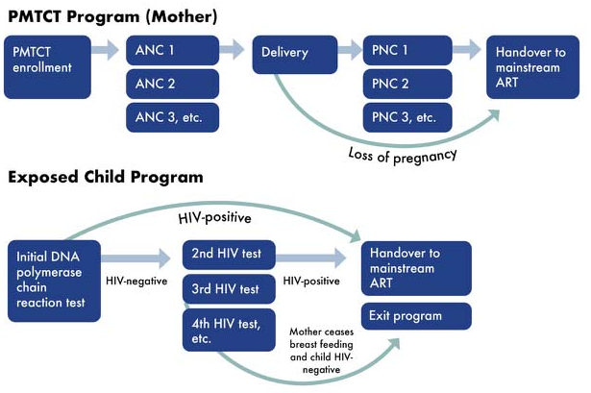
The pathway of care includes the following stages:
Mother:
- Enrollment in the PMTCT Program: This enrollment can happen any time up until the patient has delivered. If needed, a patient could be enrolled after the child’s delivery, if the delivery records are available and can be retrospectively captured.
- ANC: The sample PMTCT Tracker automatically prompts a new ANC visit one month after the previous visit, but this can be tailored to local needs. If the pregnancy terminates at any point, the patient will be handed over to mainstream ART. The patient can have an unlimited number of ANC visits up until she has delivered or the pregnancy terminates.
- Delivery: The delivery may happen in another clinic or facility, so the PMTCT Tracker allows you to register the visit as having occurred at the other clinic or facility and include contact details of that clinic or facility.
- PNC: If the delivery took place in another clinic or facility, the PMTCT Tracker allows you to refer the patient back to the original clinic for PNC.
- Handover to mainstream ART: There are three circumstances in which a patient would be handed over to mainstream ART:
- The pregnancy terminates
- The mother ceases breastfeeding
- The child tests HIV-positive
The patient is likely to receive mainstream ART in a different clinic or facility. If that clinic or facility also uses the PMTCT Tracker, you can hand over the patient using the system. If that clinic or facility does not use the PMTCT Tracker, the patient will remain in the system for your clinic or facility and will appear in overdue reports until you have received notification from the receiving clinic or facility that the patient has been enrolled in its care. In some contexts, there may not be a specific handover from the PMTCT program to the ART program. Instead, patients attend the ART program alongside the PMTCT program. When the PMTCT program is completed, they simply continue with the ART program.
- Close enrollment: After the mother’s handover to mainstream ART has been completed, the system automatically prompts you to close the mother’s enrollment.
Child:
- Enrollment in the Exposed Child Program: After the patient has delivered, the newborn child is enrolled in the Exposed Child Program.
- Initial DNA polymerase chain reaction (PCR) test: Depending on the local care schedule, the child will receive an initial DNA PCR test and follow-up tests as necessary. The sample PMTCT Tracker prompts for the child to receive the initial test within eight weeks of delivery.
- Follow-up tests: If the first test result is negative and the mother is breastfeeding, the child will receive follow-up tests. In the sample PMTCT Tracker, the next follow-up test is set for no later than six months after the initial test and will be repeated as necessary up until the mother has stopped breastfeeding. (During implementation, this interval can be adapted to the local schedule of care.) As soon as the mother stops breastfeeding, the PMTCT Tracker will prompt staff to book a final confirmatory test for the child at least six weeks after breastfeeding has ceased. If the result is negative, the child’s enrollment can then be closed. If the child tests positive, he or she will be handed over to mainstream ART.
- Handover to mainstream ART: If the child tests HIV-positive at any time, the mother and child will be handed over to mainstream ART, following any final confirmatory tests. If the mother is attending an ART Program alongside the PMTCT Program, only the child will be handed over to the ART Program because the mother is already enrolled. The child is likely to receive mainstream ART in a different clinic or facility. If that clinic or facility also uses the PMTCT Tracker, you can hand over the child using the system. If that clinic or facility does not use the PMTCT Tracker, the child will remain in the system for your clinic or facility and will appear in overdue reports until you have received notification from the receiving clinic that the child has been enrolled in its care.
- Close enrollment: After the mother stops breastfeeding, if the child’s DNA PCR test remains negative following any final confirmatory tests, then the child’s enrollment can be closed.

2.3 Confidentiality and Data Protection
Unlike most electronic health management information system tools, which capture summaries of patient numbers, the PMTCT Tracker captures information on individual patients. For this reason, the data held in the PMTCT Tracker should be treated as highly confidential, even if they do not contain names. (Note that the sample PMTCT Tracker does include telephone numbers.)
The following measures should be used to protect confidential patient data in the PMTCT Tracker, in addition to any general data protection measures that may be in place in the clinic or facility:
- Make sure that you and your colleagues have access to only the information you need to carry out your job. If a colleague needs to see only PMTCT reports, make sure that his or her login does not include “Data Capture” or “Supervision”—it should allow them to see only the PMTCT reports.
- Never share your password with anyone else, not even your supervisor or the system administrator. The system keeps a history of everything that is done by each user, so if someone else uses your login and corrupts data or breaches patient confidentiality, you will be held responsible. If you think that someone else knows your password, then change it immediately (see Section 3.5).
- Always log off when you have finished your work (see Section 3.3).
- Ensure that the screen of the computer, laptop, or tablet you are using cannot be seen by other patients or staff.
- Never download data from the PMTCT Tracker unless you have been given specific approval to do so. DHIS2 enables you to download data in MS Excel or CSV formats, but this is a confidentiality risk because these downloaded files can be easily viewed by anyone, so only authorized staff should download data.

Accessing and Navigating the PMTCT Tracker

3.1 Levels of Access to the PMTCT Tracker
To access the PMTCT Tracker, you will be registered as a user and given specific levels of access to the system based on the following three key factors: role, clinic or area for data capture, and clinic or area for reports.
Role: A user will have one of the following roles shown in Table 1.
Table 1. PMTCT Tracker user roles
User | Search, register, capture data | View patient records | View reports | View summary Dashboards | Audit access | Create public reports
Data capture
Can search for or register patient records, capture data at each stage of the pathway of care, and view reports
Supervision
Can search for and view patient records, view reports, and have audit access to the system (but cannot make changes to patient records or visit data)
Summary reports
Can view summary Dashboards but cannot see data capture screens (e.g., the Patient Dashboard) and cannot explore reports to see patient-level data
Report writing and analysis
Can create public reports that other users can see; cannot see data capture screens but can have full access to underlying patient data
Clinic or area for data capture: This determines which patient data you can view or edit in the Patient Dashboard (i.e., the Tracker Capture module). A staff member working in one clinic or facility will only be able to edit patient visits for that particular clinic or facility; a supervisor working across an area may be able to view patient data for all clinics or facilities in that area but none outside that area.
Clinic or area for reports: It is good practice for all users to have access to reports for all regions, districts, and clinics or facilities. This does not necessarily mean that they can see confidential patient data—you can still restrict these users to see only summary reports.
When you are given your own username and password for the PMTCT Tracker, you should be told what level of access you have; if this has not been explained to you, contact your supervisor or the system administrator for further details.

3.2 How to Open the PMTCT Tracker
The PMTCT Tracker is a web-based application and is available on an Internet browser whenever you have an Internet connection. For DHIS2, we recommend using the Google Chrome browser, which can be downloaded free of charge from http://www.google.com/chrome.
Open a browser and in the address bar enter the URL of the DHIS2 server that is hosting the PMTCT Tracker—ask your technical support team for help if necessary.
After you have accessed the URL, you will see the PMTCT Tracker login screen (see Section 3.3).

3.3 How to Log into and out of the PMTCT Tracker
When you see the blue login screen of the PMTCT Tracker, enter your username and password (these will be issued to you by your system administrator) to log into the system. If this information is entered incorrectly, you will see an error message asking you to re-enter your details.
When you finish your work session in the PMTCT Tracker, we recommend that you log out before closing the web page. Use the Log Out link in the upper-right corner of the screen to do this:
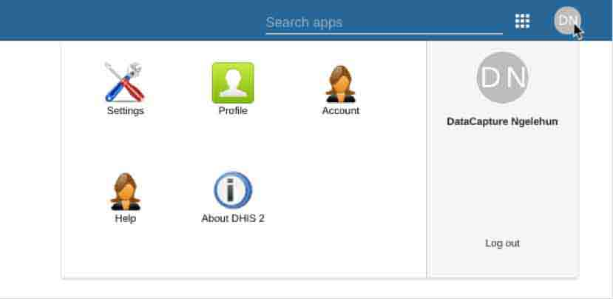
This will ensure that nobody else can open the PMTCT Tracker on your computer without entering a username and password.

3.4 Navigating the PMTCT Tracker
The PMTCT Tracker consists of several DHIS2 modules (called apps), which are used for different purposes—for example, the Tracker Capture module is used for data capture, and the Dashboard module is used to view reports and maps.

3.4.1 Navigating Modules
The PMTCT Tracker always opens to show the Tracker Capture module, which is used for data capture. You can access other modules from the top menu by clicking on “Search Apps” at the top right of the screen, and then clicking on the icon of the module you want.
Clicking on the Profile icon (gray circle, which will show your initials) in the top menu reveals additional modules that enable you to manage your user account and give you access to help and information about DHIS2.
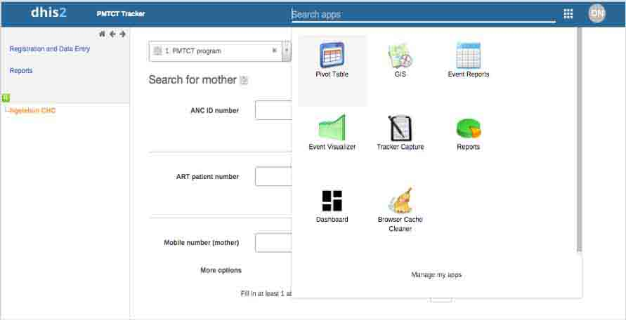
Search apps
User icon
Icons for Registration and Data Entry portal and Reports portal

The most important module is the Tracker Capture module, in which data capture and review for all PMTCT patients and children are managed. The Tracker Capture module has three screens:
- Registration and Data Entry portal: Used to search for existing patients or register new patients
- Reports portal: Shows live reports of overdue or upcoming bookings
- Patient Dashboard: Used to review patient records and capture patient data
In the Tracker Capture module, the Registration and Data Entry and Reports portals are accessed through the menu on the left-hand side of the screen. (The Tracker Capture module always opens in the Registration and Data Entry portal.) The Patient Dashboard screen is accessible only after you have searched for an existing patient or registered a new patient, which will open this screen.

3.4.2 Understanding the Layout of the Patient Dashboard
In the Tracker Capture module, the most important screen is the Patient Dashboard (the Patient Dashboard should not be confused with the Dashboard module, which presents dashboards and reports). All updates to the patient’s records are entered in the Patient Dashboard, and it shows which stage the patient has reached in the pathway of care, including progress in relation to key milestones.
You can open the Patient Dashboard either by searching for and selecting an existing patient or by registering a new patient (see Sections 5.1 and 5.2). After you have done this, you will automatically be transferred to the Patient Dashboard.
Before starting to use the PMTCT Tracker, it is important to understand the layout of the Patient Dashboard so you can easily find the information you need on a patient and can update the record as the patient’s care progresses.

Layout of the Patient Dashboard
The left-hand side of the screen shows information about the enrollment (PMTCT Program or Exposed Child Program), as well as a timeline of visits and bookings.
The right-hand side of the screen shows information about the patient (mother or child).
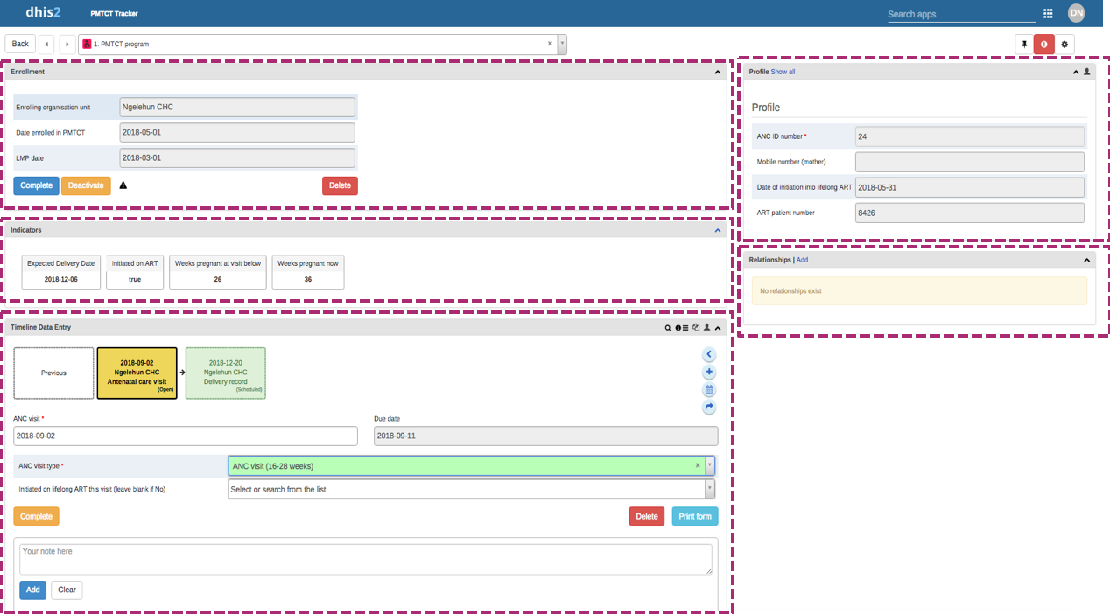
Booking date (due date) is shown on the right.
You can convert a booking into a visit by entering a visit date on the left, after which the relevant data items will be shown.
Clicking on the box for a visit or booking reveals the dates and data items that are captured for it.

Timeline data entry: This shows the patient’s history of visits and bookings, with each one shown as a box in the timeline at the top of this section. Each visit or booking matches a step in the PMTCT pathway of care (see Section 2.2).
This button ( ) creates a visit directly rather than a booking for a visit. It should not be necessary to use this button; you always want to create a booking first, and then open the booking to enter data about a visit.
These buttons are used to add new bookings at your own clinic () or to create a booking (referral) at another clinic or facility that uses the PMTCT Tracker (). As you use the PMTCT Tracker, you will be prompted to add new bookings at your own clinic, so you should not usually need to use these buttons unless you want to refer a patient to another clinic ().
Patient relationships: This records any children that a mother gives birth to during the PMTCT program. The child’s record will be listed here on the mother’s Patient Dashboard and can be accessed by clicking on it.
Patient profile: This contains basic data about the patient, including ID number, telephone number, and date of initiation into lifelong ART (if she has been initiated).
Indicators: These provide key information about the enrollment (these change as the patient progresses).
Enrollment: This shows details of the patient’s enrollment in PMTCT, including the clinic that “owns” her enrollment, the date she first enrolled, and the date of her last menstrual period.

3.5 How to Manage Your Own User Account
Each user logs into the PMTCT Tracker with his or her own personal user account (accessed by entering your username and password). This user account also holds contact details and other useful information, which you should keep updated.
Clicking on the Profile icon (grey circle) in the top menu reveals additional modules that enable you to manage your user account and also gives you access to help and information about DHIS2.
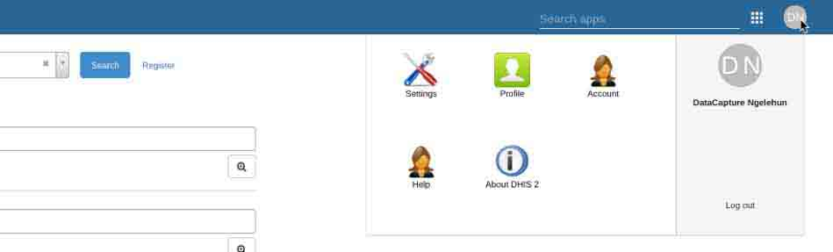

The module for managing your user account includes the following:
- Account: This is where you can change your confidential password.
- Profile: This is where you can include contact information and details about your role.
- Help: This takes you to a website containing this User Manual and other documentation for the PMTCT Tracker.
- About DHIS2: This provides details about the version of DHIS2 that you are using and also shows the date and time that Dashboard reports were last updated (“Last analytics table generation”).

4. Data Capture and Review: General Principles
Throughout the system, various fields enable you to capture data. Three main types of data capture are possible: free-text boxes, drop-down lists, and dates.
Free-text boxes: Use these text boxes to enter any kind of text (e.g., a name or telephone number). To change text that has already been entered, simply click in the box and type over the old value.
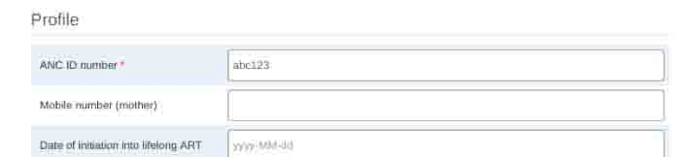
Drop-down lists: Click on the small triangle in the right-hand side of the list, and then click on one of the options that appears in the drop-down list. If you want to change the option you have selected, you can simply select another option. If you want to delete what you have selected (and leave the box blank), click on the “x” to the right of the value.
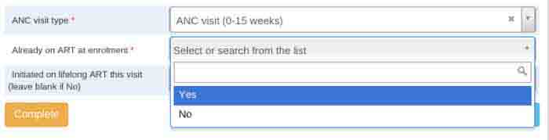

Dates: Use the calendar to select the date you want. Choose the month and year using the drop-down lists at the top, and then click on the date you want to select. If you want to change the date that has been selected, you can simply select another date. If you want to delete what you have selected (and leave the box blank), select the date showing in the box and click on the “delete” key. In some instances, the system automatically generates a date, so always check the date and adjust it as necessary. The PMTCT Tracker uses the date format YYYY/MM/DD (e.g., 2018/12/31), so it is important to always ensure that dates are entered in the correct order.
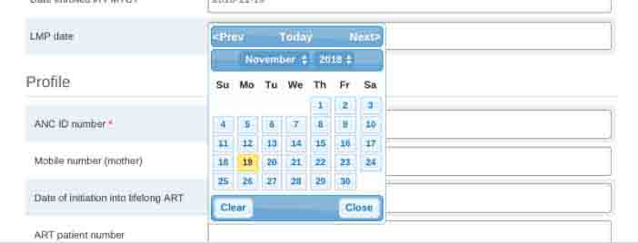

4.1 How Data Are Saved
Registering a new patient: When you register a new patient, the data you enter will only be saved when you click on the blue “Save and continue” button. If there is a mistake and the patient does not need to be registered, you can click on “Cancel” at any time. (Never click on the “Save and add new” button because this will start the registration process for another patient, rather than continuing to update the enrollment visit.)
Using the Patient Dashboard: When you reach the Patient Dashboard, all data are automatically saved as you move from box to box on the screen. As soon as you have entered data, the box will turn green, which confirms that the data you have entered have been saved—there is no need to click on a “Save” button:
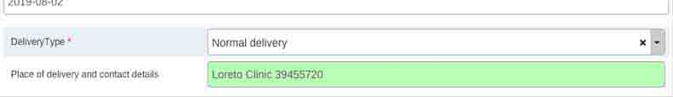
(Note: If the box turns red, you may be disconnected from the server—see Section 4.2, Temporary Interruptions to the Internet.)
Creating relationships: When you create a related child, you are in fact registering a child in the system. The child’s details will not be stored in the system until you click on the “Save” button.

4.2 Temporary Interruptions to the Internet
You should be connected to the Internet when using the PMTCT Tracker. It is not possible to enter and save data if you are offline. If the Internet connection is interrupted, any data you enter will not be saved until the connection is restored. When you first open the Tracker Capture module, you should see the following yellow box at the top of the screen:
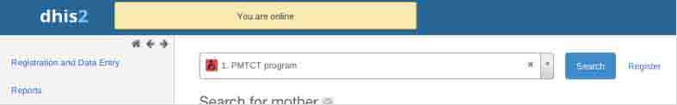
If you lose your Internet connection at any point, the following message will appear:
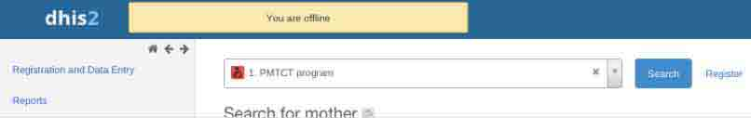

Warning: If your connection is interrupted, do not use the Browser Cache Cleaner until you have connected again and the data you have entered in the current screen have been saved. If you run the Browser Cache Cleaner, it will wipe all information that is being temporarily stored, including offline data capture.

4.3 Validation Rules, Warnings, and Errors
The PMTCT Tracker includes a wide range of checks and validation rules, which monitor the data you are capturing and alert you if you appear to be making an error. The alert will display as a pop-up window over the screen in which you are working.
There are two types of alerts:
- Warnings alert you about a potential issue or remind you to do something, but they do not stop you from continuing to do what you are doing. These appear in yellow:
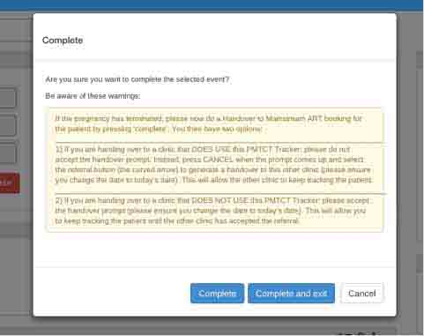
- Errors alert you about something that is incorrect and stop you from continuing until the error is fixed. These appear in red:
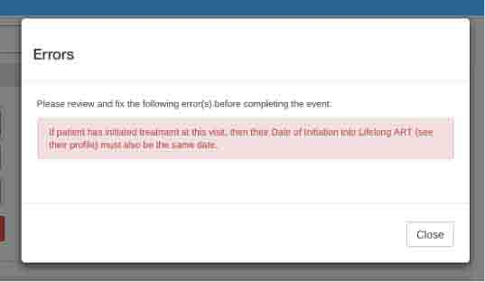
Make sure that you closely follow all instructions that are given in these warnings and errors.

4.4 Audit Trails
Because the PMTCT Tracker contains confidential patient data, all user actions are recorded in a log that can be viewed by system administrators. Even searching for a patient or viewing a patient record will be recorded in the log.
Every Data Capture and Supervision user is able to view the audit trail of edits to a patient record, which includes any action related to that record. This can be useful if data for a patient have changed and the Data Capture and Supervision users want to understand who changed the data and how. To see the audit trail, open the Patient Dashboard. On the Timeline, click on the patient head icon (). This will open an audit trail that shows each edit that has been made to the record and who made it.
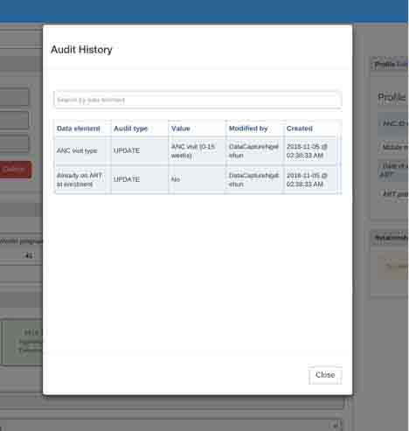

5. Data Capture and Review: Mother’s PMTCT Program
Important note: Only Data Capture and Supervision users will be able to access the screens described in this section, and only Data Capture users will be able to capture and edit data. Supervision users can only view data.
Data about the pregnant woman or mother are entered in the Tracker Capture module. The data are recorded for a patient at the clinic or facility level, and previous data can be added. Data can also be entered at the time of an appointment. The PMTCT Tracker can also capture data about future appointments and milestones.

5.1 How to Search for an Existing Patient
- Enter search details: After you are in the Tracker Capture module, you will see the Search screen. If you have access to more than one clinic or facility, select the one you would like to search from the list on the left-hand side of the screen. Then enter the patient’s ANC ID number, ART patient number, or telephone number in the appropriate box. (During implementation, these IDs and search parameters can be adjusted for the local context.)
- Start the search: Click on the magnifying glass icon to start the search. (The blue “Search” button does not start a search; it simply opens the Search screen.)

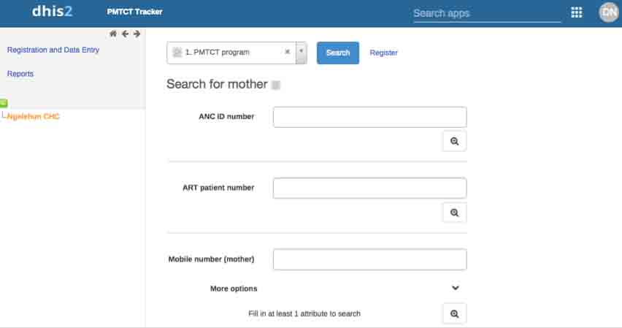
Use the magnifying glass icon to search for an existing patient.
The ‘Search” button opens the Search screen; you cannot use this button to search for an existing patient.

5.2 How to Register and Enroll a New Patient
- Click on the “Register” button, which will open the following screen:
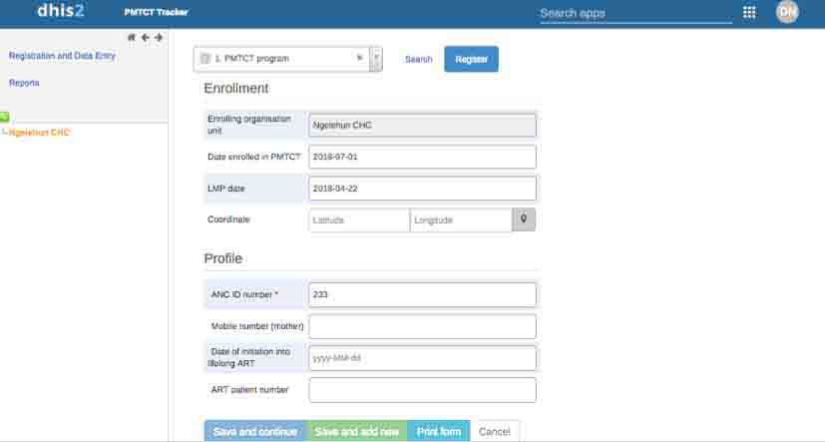

- Enter the following data on this screen:
Mandatory data:
- Enrolling organization unit: By default, the patient will be registered at the clinic or facility that is selected on the left (orange highlight). This will automatically show in the “Enrolling organization unit” box. This clinic or facility “owns” the patient enrollment.
- Date patient enrolled in PMTCT: This will auto-populate with today’s date; change this to the correct enrollment date if you are not capturing data on the same day.
- Date of the patient’s last menstrual period (LMP): This will auto-populate with today’s date but must be changed to the correct LMP date reported by the patient (see footnote below).
- ANC ID number: The ANC ID that the patient is issued at enrollment should be entered in this field. If you receive an error message when you enter the ID number (e.g., “Value not unique”), you may find that the patient has been registered or enrolled for a previous pregnancy, so her data are already in the system. In this case, you do not need to register the patient again. Search for the patient’s record and start a new enrollment by clicking on “Add new” in the Enrollment section of the Patient dashboard.
Optional data:
- Mobile number (mother): If the mother has a mobile phone, the system can send an automated Short Message Service (SMS) reminder if a booking has been missed, and clinic or facility staff can make follow-up calls. This is the only identifying data captured for the patient.
- Date of initiation into lifelong ART: If a patient is already on lifelong ART, enter the date that she was initiated into treatment. Leave this blank if she has not yet been initiated. If she is initiated during this enrollment visit, enter the date of this visit.
- ART patient number: If the patient is on ART, enter her ART ID number; otherwise leave this blank.
- To complete the patient registration, click on “Save and continue.” This will take you to the Patient Dashboard to complete the details about this visit. Important note: The automatically generated dates for “Date enrolled in PMTCT” and “LMP date” cannot be adjusted after you have clicked on “Save and continue.” If you forget to change these dates, you will need to delete the enrollment record and start again (see Section 5.4 for details on how to do this).
- The enrollment visit will be recorded as the first ANC visit—you will see this shown in a colored box in the Timeline Data Entry, called “PMTCT enrollment visit.” You will need to complete the data about the visit (see Section 5.5 for details on how to do this).
- When you complete this enrollment (by clicking on the orange “Complete” button), a pop-up message will prompt you to book the next ANC visit. The sample PMTCT Tracker is set to prompt ANC visits at one-month intervals after the enrollment visit, but you can change this date manually.
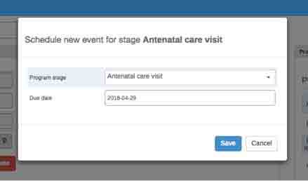

5.3 How to Enroll a Mother if Her Child Has Been Delivered
If a patient enrolls in the PMTCT Program after her child has been delivered, enter the date that she has enrolled. You can then enter the child’s birth details and register the child, even though the birth happened before the enrollment date.

5.4 How to Delete an Enrollment
If you made an error when creating a patient enrollment and need to delete the enrollment (e.g., if you forgot to change the automatically generated dates for “Date enrolled in PMTCT” or “LMP date” before saving the enrollment), click on the “Delete” button in the Enrollment section of the Patient Dashboard. This will delete all information relating to this specific enrollment while retaining the registration data entered in the Profile section. Then search for the patient’s record using her unique ID and click on “Add new” in the Enrollment section. Do not click on the red square in the right-hand corner (the “Manage mother” icon), because this will delete all information about the mother in the system, including enrollments for previous pregnancies.

5.5 How to Capture Data about a Completed ANC Visit and Schedule a Follow-up Visit
Data about an ANC visit are captured in the Timeline Data Entry section of the Patient Dashboard in the “Antenatal care visit” box (see Section 3.4.2 for details on the layout of the Patient Dashboard).
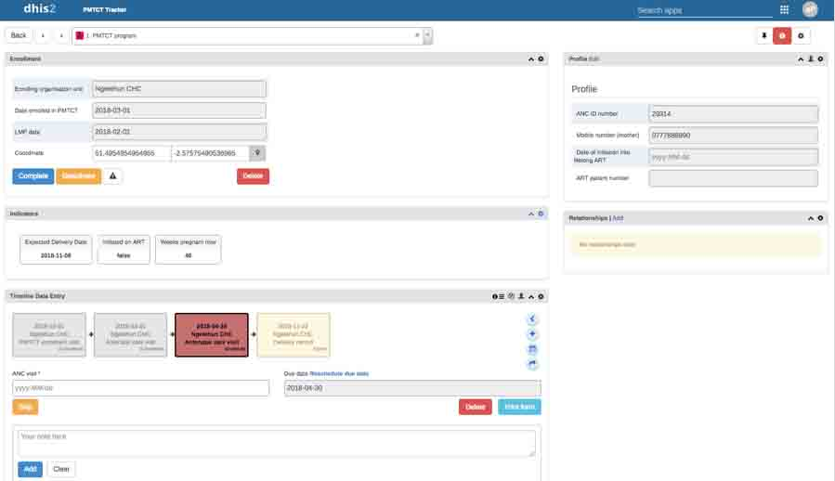
To enter data about a completed ANC visit and schedule a follow-up visit, click on the “Antenatal care visit” box in the Timeline Data Entry section. The box will either be green (if the visit is not yet due) or red (if the visit is overdue). Follow these steps to enter the data:
- ANC visit: Enter the date the visit took place in the green “ANC visit” box. If the patient comes in for an unscheduled visit, use the existing booking in the system to capture data for this visit and complete the visit. Then follow the prompts to schedule a new booking, adjusting the automatically generated date to the date of the original booking or to the appropriate revised date.
- ANC visit type: Select the type of visit from the drop-down list.
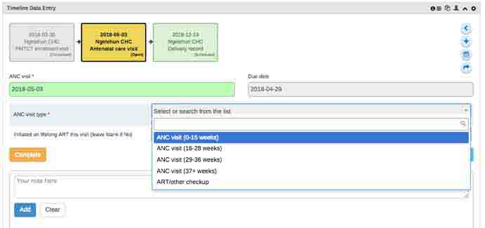
- Initiated on lifelong ART this visit: If the patient was initiated on ART this visit, select “Yes.” You will also need to update the Profile data by adding the date of this visit to the “Date of initiation into lifelong ART” box. Click on the blue “Edit” button at the top of the Profile section to make changes to the Profile.
- Complete: Once you have entered the data, click on the orange “Complete” button. A pop-up message will ask you to confirm whether you want to complete. Click on the “Complete” button, which will allow you to book the next ANC visit. If you click on “Complete and exit,” you will leave the patient’s record without having booked a follow-up visit.
- Pop-up: A pop-up message will prompt you to schedule the next ANC visit. Check the automatically generated date of the next ANC visit and change it if necessary. Then click on the blue “Save” button. You can see this ANC visit now scheduled in a box in the Timeline Data Entry section.
- Exit: You can now exit the Patient Dashboard for this patient and return to the Patient Search screen by clicking on the “Back” button in the top left-hand corner.

5.6 How to Capture Data about a Delivery or End of Pregnancy
Data about a delivery or end of pregnancy are entered in the Timeline Data Entry Section of the Patient Dashboard (see Section 3.4.2 for details on the layout of the Patient Dashboard).
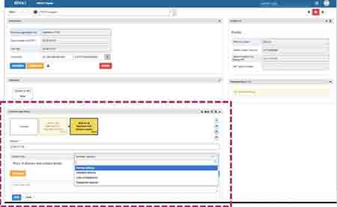
Follow these steps to capture data about a delivery or end of pregnancy:
- Delivery record box: Open the “Delivery record” box in the Timeline Data Entry section. If there have been a number of ANC visits, you may need to click on the “Next” box to scroll through the visits to find it.
- Delivery: Enter the date of the delivery.
- Delivery type: Select the type of delivery from the drop-down menu. If the patient’s pregnancy has terminated, the system will prompt handover to mainstream ART when the delivery record is completed. See Section 5.8 for details on how to record a handover to mainstream ART.
- Place of delivery and contact details: If the delivery did not occur in this clinic or facility, enter the location of the delivery and contact details for the clinic or facility where it occurred.
- Complete: When you have finished entering data, click on the orange “Complete” button.
- Pop-up message: A pop-up message will prompt you to click on “Complete” and will guide you through the following steps:
- Book the first PNC visit: See guidance in Section 5.7.1 on how to book the first PNC visit.
- Delete any open (incomplete) ANC bookings: Click on the open “Antenatal care visit” box (it will be marked as “open” in the bottom right-hand corner of the box and will be colored yellow or red) and then click on the red “Delete” button in the right-hand corner of the Timeline Data Entry box. If these bookings were made by another clinic, you will not be able to delete them; the other clinic will have to delete them.
- Enroll the child in the Exposed Child program: See the steps in Section 6.1 for enrolling the newborn child in the Exposed Child program.
- Exit: You can now exit the Patient Dashboard for this patient and return to the Patient Search screen by clicking on the “Back” button in the top left-hand corner.
If a mother becomes pregnant during PNC for the current birth, close the existing enrollment of the mother using the blue “Complete” button in the upper left-hand corner of the screen (delete any pending PNC appointments first). Then start a new enrollment for her next pregnancy using the “Add new” button in the Enrollment section of the Patient Dashboard. This allows the first child’s care pathway to still be tracked, while the mother will start a new care pathway for her subsequent pregnancy.
If a mother dies during labor, enter this information in the comment box at the bottom of the screen. Complete the rest of the delivery information about the child but cancel the automatic pop-up to schedule a PNC visit. Then enroll the child in the Exposed Child program (see Section 6.1). Finally, close the mother’s enrollment by clicking on the blue “Complete” button in the upper left-hand corner of the screen.

5.7 How to Enter Data about a PNC Visit
Data about a PNC visit are entered in the Timeline Data Entry section of the Patient Dashboard (see Section 3.4.2 for details on the layout of the Patient Dashboard).
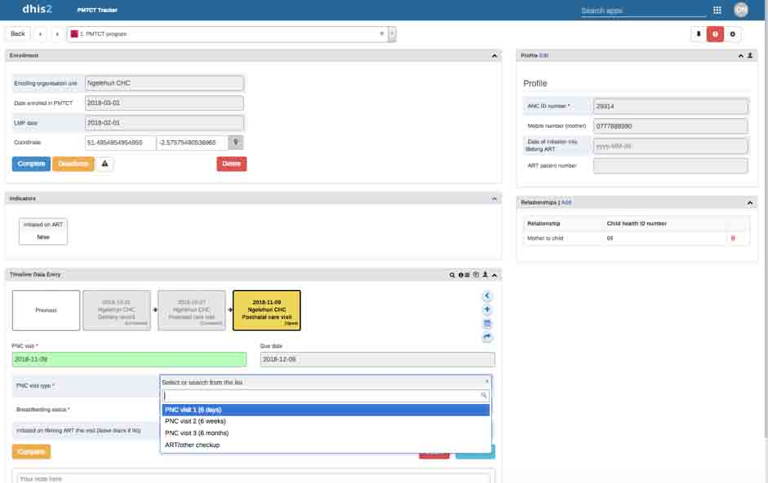

5.7.1 Schedule the First PNC Visit
When the newborn child’s delivery information is entered in the mother’s Patient Dashboard, there will be an automatic prompt to schedule the mother’s first PNC visit.
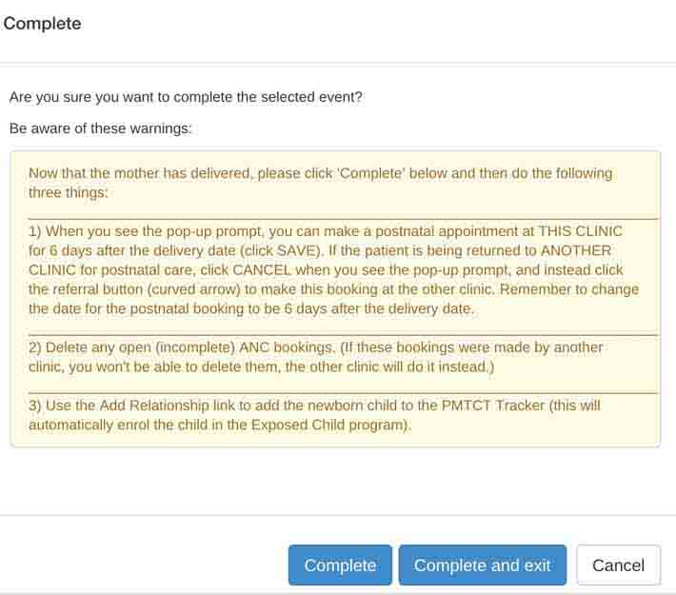
- PNC taking place in the same clinic or facility: If PNC will take place at the same clinic or facility as the delivery, click on “Complete” to make a postnatal appointment. An automatic pop-up box will prompt you to schedule the PNC visit. Change the automatically generated date for the booking to be six days after the delivery date.
- PNC taking place in another clinic or facility: If PNC will take place at another clinic or facility, click on “Cancel” when prompted and then click on the referral button (curved arrow in the Timeline Data Entry section) to make this booking at the other clinic or facility. Change the automatically generated date for the booking to be six days after the delivery date.
After the first PNC visit, each time you enter data about a completed PNC visit (by clicking on the orange “Complete” button), a pop-up message will prompt you to book the next PNC visit. The sample PMTCT Tracker includes PNC follow-up visits every 30 days, but you can change this date manually for each visit (and the system can be configured to change this interval).

5.7.2 Enter Data about a Completed PNC Visit and Schedule a Follow-Up Visit
Data about a completed PNC visit are entered by clicking on the “Postnatal care visit” box in the Timeline Data Entry section. It will be either green (if not yet due) or red (if overdue). After you start entering data, the box will turn yellow (in progress) until you click on the “Complete” button.

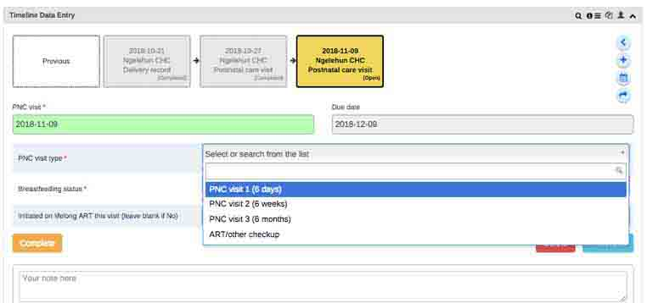
Follow these steps to enter data about a completed PNC visit and schedule a follow-up visit:
- PNC visit: Enter the date the visit took place in the “PNC visit” box. If the patient comes in for an unscheduled visit, use the existing booking in the system to capture data for this visit and complete that visit. Then follow the prompts to schedule a new booking, adjusting the automatically generated date to the date of the original booking or to the appropriate revised date.
- PNC visit type: Select the visit type from the drop-down list.
- Breastfeeding status: Select the breastfeeding status from the drop-down list. If the status is “Permanently ceased breastfeeding,” the system will prompt the mother’s handover to mainstream ART and final confirmatory tests for the child when you complete and save this PNC record (see Section 5.8 for the steps to do this). If the breastfeeding status is “unknown,” the system will respond as if breastfeeding is continuing until otherwise confirmed.
- Initiated on lifelong ART this visit: If the patient was initiated on ART this visit, select “Yes.” You will also need to update the Profile data by adding the date of this visit to the “Date of initiation into lifelong ART” box. Click on the blue “Edit” button at the top of the Profile section to make changes to the Profile.
- Complete: Click on the orange “Complete” button. A pop-up message will ask you to confirm that you want to complete. Click on the “Complete” button to book the next PNC visit. If you click on “Complete and exit,” you will leave patient’s record and will not have the opportunity to book a follow-up visit.
- Pop-up: A pop-up message will prompt you to schedule the next PNC visit. Check the automatically generated date of the next PNC visit and change it if necessary. Then click on the blue “Save” button.
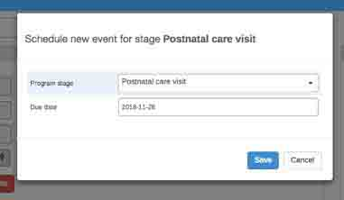
Exit: You can now exit the Patient Dashboard for this patient and return to the Patient Search screen by clicking on the “Back” button in the top left-hand corner.

5.8 How to Hand Over to Mainstream ART (Mother)
There are three instances in which a pregnant woman or mother would be handed over to mainstream ART:
- Pregnancy terminates
- Mother ceases breastfeeding
- Child tests HIV-positive, in which case both mother and child would be handed over to mainstream ART
When recording any of these instances in the system, you will receive an automatic prompt to hand over the patient to mainstream ART. The automatic prompt will guide you through the following steps:
Handover to clinic that uses the PMTCT Tracker
Change the date
Select “Move permanently”
- If handing over to a clinic or facility that uses the PMTCT Tracker: Do not accept the “Mother handover to ART” prompt. Click on “Cancel” when the prompt appears and select the referral button (the curved arrow in the Timeline Data Entry section) to generate a handover to the other clinic or facility. Ensure that you change the date to the correct handover date and click on “Move permanently” (see screenshot on the right-hand side of this page). This will allow the other clinic to close the PMTCT enrollment after it has accepted the ART referral.
- If handing over to a clinic or facility that does not use the PMTCT Tracker: Accept the “Mother handover to ART” prompt by clicking on “Save” and ensure that you change the date to the correct handover date. This will allow your clinic or facility to keep tracking the patient in your system until the other clinic or facility has accepted the referral.
Handover to clinic that does not use the PMTCT Tracker
If the mother has a related child record, after you have completed the request to hand over the mother to ART, switch to the Exposed Child program (using the “Relationships” box) and book a final DNA PCR test for the child (see Section 6.3 for details on how to book a DNA PCR test).
After the ART referral has been accepted, the patient’s enrollment will need to be closed (see Section 5.9).

5.9 How to Complete a Handover to Mainstream ART and Close a Mother’s Enrollment
When a request for handover to mainstream ART has been accepted by the receiving clinic or facility, this should be captured in the PMTCT Tracker, and the enrollment should then be closed.
If the receiving clinic or facility is using the PMTCT Tracker, it will capture the handover outcome data and will then be prompted to close the enrollment.
If the receiving clinic or facility is not using the PMTCT Tracker, then the clinic or facility that sent the handover request will capture the handover outcome data and close the enrollment. The steps to do this are as follows:
- Date handover accepted: Click on the “Mother handover to ART” box in the Timeline Data Entry section of the Patient Dashboard and enter the date the handover was accepted (make sure that you change the automatically generated date, which defaults to the LMP date).
- Outcome of handover to mainstream ART: Select from the drop-down list whether the patient was successfully handed over to lifelong ART, refused treatment, or died before treatment started. Click on the orange “Complete” button.
- Complete: You will then be prompted to click on the “Complete event and enrollment” button.
After the enrollment has been closed, the patient’s data will still be visible, but you will not be able to make any edits. Do not click on the “Deactivate mother” button (a red square with an exclamation mark in the top right-hand corner of the Patient Dashboard )—this button will delete the entire profile of the mother, including any other programs in which she might be enrolled.

Note: Before closing an enrollment, always ensure that the patient’s handover has been accepted by the receiving clinic or facility, so she does not get lost to care at this stage. If the patient stopped breastfeeding, also ensure that the patient’s child has had the necessary confirmatory tests scheduled (see Section 6.3 for details on how to book a DNA PCR test).
Do not use this button—it will delete the patient’s entire record.
Click on “Complete event and enrollment” to close the enrollment.
Ensure that any children in the Exposed Child Program have had final tests scheduled.

6. Data Capture and Review: Exposed Child Program
Important note: Only Data Capture and Supervision users will be able to access the screens described in this section, and only Data Capture users will be able to capture and edit data.
Data about a child are entered in the Tracker Capture module. The data are recorded for the child at the clinic or facility level, and previous data can be entered. Data can also be entered at the time of an appointment. The PMTCT Tracker can also capture data about future appointments and milestones.

6.1 How to Enroll a Newborn Child and Link This Record to the Mother’s Record
A newborn child is enrolled in the Exposed Child program through the Relationships section on the mother’s Patient Dashboard (see Section 3.4.2 for details on the layout of the Patient Dashboard). The child should be enrolled as soon as the mother’s delivery has been recorded in the PMTCT Tracker.
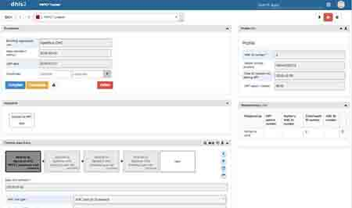
Use the Relationships section to enroll a newborn child in the Exposed Child program.
Follow these steps to enroll the child:
- Relationships: Use the “Add Relationship” link on the right-hand side of the Patient Dashboard to add the newborn child to the PMTCT Tracker. This will automatically enroll the child in the Exposed Child program.
- Add: Click the on the blue “Add” button to generate a relationship.
- Add relationship pop-up screen: A pop-up screen will ask you to add a relationship. Select “Mother-to-child” in the drop-down menu (this is the only relationship that will be available in the menu).
- Register: Click on the green “Register” button to register the newborn child. A box will open up with fields for you to enter the following data about the child and their mother (steps 5 to 11 – see screenshot below).
- Enrolling organization unit: This field will be prepopulated with your clinic or facility.
- Date of birth: Make sure that the date of birth of the child is correct (it will be prepopulated with today’s date).
- Child’s health ID: Enter the child’s health ID.
- Child’s date of initiation into lifelong ART: At the time of registration, the child is unlikely to have already been initiated into lifelong ART, so in most instances you will leave this blank.
- Mother’s contact number: This information will automatically transfer from the mother’s record if it has been captured. If it has not been captured yet, it can be added manually.
- Mother’s ANC number: This information will show in the left-hand column of the box
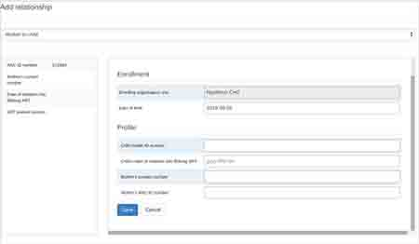
(showing as ANC ID number) and should be entered again here.

- Save: Click on the blue “Save” button to create the child’s enrollment.

6.2 How to View a Child’s Record
After a child has been enrolled in the Exposed Child program, you can access the record in two ways.
You can access the child’s record through the Search function in the Tracker Capture module, as follows:
- Exposed Child program: When you enter the Tracker Capture module, you will be presented with the PMTCT Program. Use the drop-down men in the “Search” box to select the Exposed Child program.
- Child’s health ID: Enter the child’s health ID or other identifying information, as listed on the screen.
- Magnifying glass: Click on the magnifying glass to search for the child’s record.
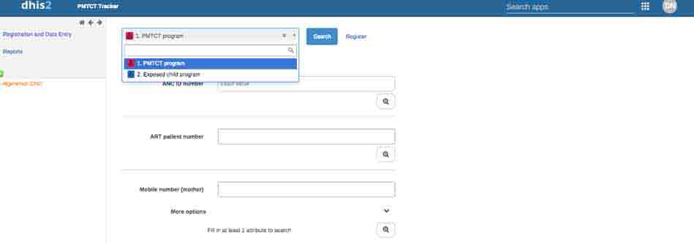
You can also access the child’s record through the Relationships section of the mother’s Patient Dashboard in the Tracker Capture module, as follows:
- Mother to child: In the Relationships box, select the text “Mother to child,” and you will be transferred to an empty Patient Dashboard screen.
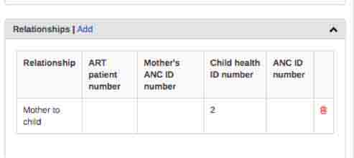
- Exposed Child program: Use the drop-down menu in the “Search” box to select the Exposed Child program. This will open the child’s Patient Dashboard.
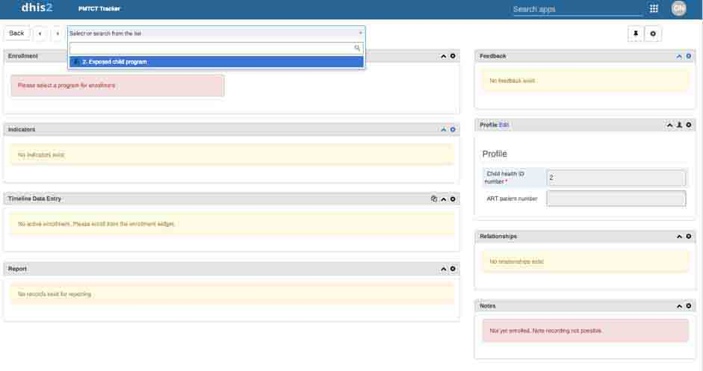

6.3 How to Schedule and Enter Data about a DNA PCR Test
Data about DNA PCR tests are entered in the Timeline Data Entry section of the child’s Patient Dashboard (see Section 3.4.2 for details on the layout of the Patient Dashboard).

6.3.1 Schedule the First DNA PCR Test
When a child is registered in the Exposed Child program, the PMTCT Tracker will automatically schedule the first DNA PCR test. The sample PMTCT Tracker will schedule the test for eight weeks after delivery, but this can be configured to meet local requirements. The date can be rescheduled by clicking on “Reschedule due date.” The test is now booked, and you can either return to the search screen using the “Back” button at the top left-hand side of the page or you can log out.
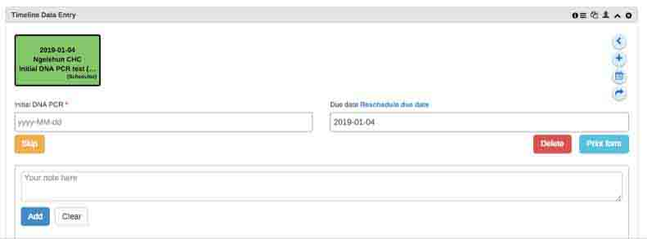

6.3.2 Enter Data about a Completed DNA PCR Test and Schedule a Follow-up Test
Click on the “Initial DNA PCR test” or “Follow-up DNA PCR test” box in the Timeline Data Entry section. It will be either green (if not yet due) or red (if overdue). Then follow these steps to enter the data:
- Initial DNA PCR/Follow-up of DNA PCR: Enter the date the visit took place. If the child comes in for an unscheduled visit, use the existing booking in the system to capture data for this visit and complete the visit. Then follow the prompts to schedule a new booking, adjusting the automatically generated date to the date of the original booking or to the appropriate revised date.
- Breastfeeding status: Select the status from the drop-down menu. If the status is “Permanently ceased breastfeeding,” the system will prompt you to do a final test six weeks after breastfeeding ceased when you complete and save the record of this visit. If the breastfeeding status is “unknown,” the system will respond as if breastfeeding is continuing until otherwise confirmed.
- Outcome of DNA PCR test:
- If the test result is available: Select the test outcome from the drop-down menu. If the child tests positive, the system will prompt you to do a handover to mainstream ART for the child (see Section 6.4). If the test is negative, the system will generate a booking for another follow-up test. The sample PMTCT tracker is set to schedule a follow-up test six months after the previous test, but you can change the date manually (and the system can be configured according to local requirements).
- If the test result is not yet available: Leave this drop-down section blank and do not complete the booking. Do not click on the “Complete” button. Exit the screen by clicking on the “Back” button in the top left-hand corner. By doing this, you will leave the appointment open until the results have been received and then the booking can be completed, as per Steps 4–6. In this scenario, you will need to manually book the next appointment, because an automatic pop-up will not be triggered because the appointment has not been completed. Use the calendar icon ( ) to generate the next appointment, ensuring that the correct date is entered.
- Complete: After you have captured all necessary data, click on the orange “Complete” button.
- Pop-up: A pop-up message will prompt you to schedule the follow-up DNA PCR test or the handover to mainstream ART, as relevant. Click on the blue “Save” or “Complete” button. Do not click on the “Complete and exit” button because you will not be able to schedule the necessary future visits.
- Exit: You can now exit the Patient Dashboard for this patient and return to the Patient Search screen by clicking on the “Back” button in the top left-hand corner.
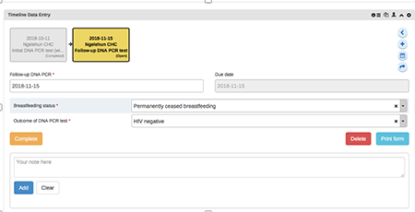

6.4 How to Hand Over a Child to Mainstream ART
If a child tests HIV-positive, the user will be prompted to book a handover to mainstream ART. The automatic prompt will guide you through the following steps:
- If handing over to a clinic or facility that uses the PMTCT Tracker: Do not accept the handover prompt (see the screenshot below). Instead, click on “Cancel” when the prompt appears and select the referral button (the curved arrow ) in the Timeline Data Entry section to generate a handover to the other clinic or facility. Be sure to change the date to today’s date and click on “Moved permanently.” This will allow the other clinic to accept the handover and keep tracking the patient.
- If handing over to a clinic or facility that does not use the PMTCT Tracker: Accept the handover prompt (be sure to change the date to today’s date) (see the screenshot below). This will ensure that the patient continues to appear on your own tracking reports until you record that the patient has been accepted by the other clinic or facility.

6.5 How to Complete a Handover to Mainstream ART and Close a Child’s Enrollment
When a request for a child’s handover to mainstream ART has been accepted by the receiving clinic or facility, this should be captured in the PMTCT Tracker, and the child’s enrollment should then be closed.
If the receiving clinic or facility is using the PMTCT Tracker, it will capture the handover outcome data and will then be prompted to close the enrollment.
If the receiving clinic or facility is not using the PMTCT Tracker, then the clinic or facility that sent the handover request will capture the handover outcome data and close the enrollment. The steps to do this are as follows:
- Date handover accepted: Click on the “Child handover to ART” box in the Timeline Data Entry section of the Patient Dashboard and enter the date that the handover was accepted (make sure that you change the automatically generated date, which defaults to the LMP date).
2. Outcome of handover to mainstream ART: Select from the drop-down list whether the patient was successfully handed over to lifelong ART, refused treatment, or died before treatment started. Then click on the orange “Complete” button.
3. Complete: You will then be prompted to click on the “Complete event and enrollment” button.
After the enrollment has been closed, the patient’s data will still be visible, but you will not be able to make any edits. Do not click on the “Deactivate child” button (a red square with an exclamation mark in the top right-hand corner of the Patient Dashboard )—this button will delete the entire profile of the child, including any other programs in which the child might be enrolled.
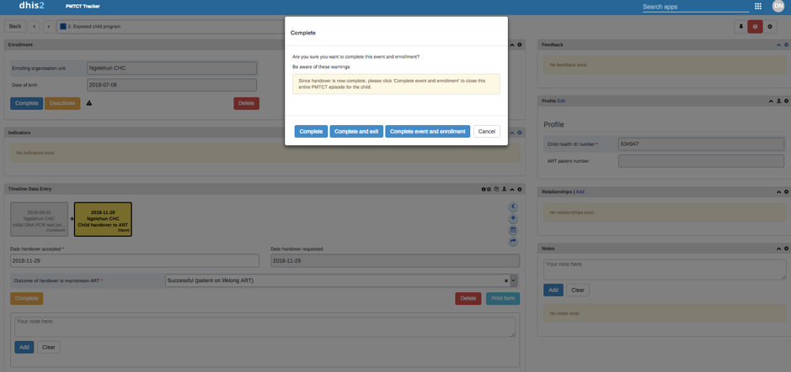
Do not use this button—it will delete the patient’s entire record.
Click on “Complete event and enrollment” to close the enrollment.

6.6 How to Close a Child’s Enrollment if Child’s Final Test Is HIV-Negative
If a mother ceases breastfeeding her child, the child should (at least six weeks later) be given another, final DNA PCR test. Staff will have been prompted to book this final test when the mother ceases breastfeeding. If the result of this final test is still negative, you can close the child’s enrollment in the Exposed Child program. To do this, follow these steps:
- Complete the visit: Click on the orange “Complete” button in the Timeline Data Entry to complete the final test booking (it will then say “Incomplete”).
- Cancel booking prompt: Cancel the automatic prompt to schedule a follow-up visit.
- Complete the enrollment: Click on the blue “Complete” button in the Enrollment section of the child’s Patient Dashboard. The data for this enrollment will still be visible, but you will not be able to make any edits to them.
After the enrollment has been completed, the child’s data will still be visible, but you will not be able to make any edits to the data. Do not click on the “Deactivate child” button (a red square with an exclamation mark in the top right-hand corner of the Patient Dashboard )—this button will delete the entire profile of the child, including any other programs in which the child might be enrolled.
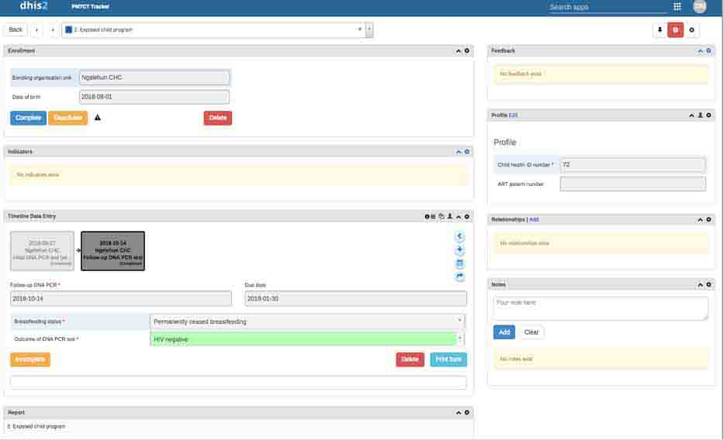

7. How to Track a Patient Between Clinics or Facilities
Important note: Only a Data Capture user will be able to make and accept referrals.
A mother and child may change the clinic or facility in which they receive their care at any point during their enrollment in a PMTCT Program. The most likely points at which they will change the clinic or facility are:
- Delivery: This is likely to be a temporary handover specifically for the patient’s delivery, after which she returns to the original clinic or facility for PNC.
- Handover to mainstream ART: This will be a permanent handover to a clinic or facility that provides mainstream ART care.
The PMTCT Tracker enables care providers to track a patient between clinics or facilities by giving the clinic or facility ownership over each booking. When a patient is referred by one clinic or facility to another, ownership of either one booking or the whole enrollment is transferred to the new clinic or facility. Ownership means that the clinic or facility is responsible for tracking that patient; the bookings owned by the clinic or facility will be visible in its upcoming and overdue reports to enable tracking of the patient.
It is important to note that any clinic or facility using the PMTCT Tracker can edit or complete an open booking, regardless of which clinic or facility has ownership of that booking. This is because a patient can visit any clinic or facility during any point in her PMTCT care, so care providers at any clinic or facility need to be able to capture data for that visit in the system. Until they do this, however, the patient will remain on the upcoming and overdue reports of the clinic or facility that has ownership of that patient.
After a visit has taken place and is entered as “completed” in the PMTCT Tracker by a particular clinic or facility, only staff at that clinic or facility can make changes to the closed booking. This prevents staff in different clinics or facilities from modifying each other’s records.
How to make a referral
Change the date.
Select “One-time referral” or “Move permanently.”

7.1 How to Make a Referral
To refer a patient to another clinic or facility that uses the PMTCT Tracker, take the following steps:
- Click on the curved arrow in the Timeline Data Entry section.
- Select the correct facility from the “Organization unit” list.
- Make sure to check and adjust the automatically generated date for the booking.
- Select either “One-time referral” or “Move permanently,” as appropriate. “One-time referral” transfers ownership of only the new booking. “Move permanently” transfers ownership of both the new booking and the patient’s ongoing enrollment.
To refer a patient to another clinic or facility that does not use the PMTCT Tracker, take the following steps:
- You should be automatically prompted to make a new booking. Then follow the prompts to book the next appointment.
- Click on “save.” This keeps ownership of the booking with the current clinic or facility. The patient will continue to appear on upcoming and overdue reports, and staff at the clinic or facility can track the patient until they are sure that the patient has been received at the new clinic or facility. The original clinic or facility will need to inform the new facility or clinic of the referral. After the referral has been confirmed, the original clinic or facility should close the mother’s enrollment in the system.
If you are making a referral after a delivery, you will receive pop-up guidance in the system to take you through other steps you need to complete as part of the handover (see Section 6, step 6 for further details of how to do this).
If you are making a referral when handing over to mainstream ART, you will receive pop-up guidance in the system to take you through other steps you need to complete as part of the handover (see Section 5.8 for further details of how to do this).

7.2 How to Accept a Referral
If a patient has been referred to a clinic or facility using the PMTCT Tracker, the receiving clinic or facility will then own that booking, and it will start appearing in the tracking lists. The clinic or facility “accepts” the referral by starting to enter data about a visit (alternatively, any other clinic or facility can also take over this booking, in the case that the patient attends a different clinic or facility to the one they were referred to).
If the receiving clinic or facility does not use the PMTCT Tracker, the original clinic or facility will need to inform the new clinic or facility of the referral. After the referral has been confirmed, the original clinic or facility should update the system and then close the mother’s enrollment.

8. Actively Track and Follow up on PMTCT Patients
Important note: Only Data Capture and Supervision users will be able to use the patient tracking features described in this section.
The PMTCT Tracker is designed to help you track your PMTCT patients over time and alert you to potential delays in care before a patient becomes lost to follow-up, so you can ensure that all patients complete the full pathway of care. The PMTCT Tracker includes two tools for doing this, and using these tools should be part of the daily routine in your clinic or facility.
The two tools are as follows:
- The Tracker Capture module’s Overdue Events reports and Upcoming Events reports keep you updated on patients who have an upcoming visit or delivery and patients who have missed a visit or delivery.
- Automated SMS notifications are sent to patients (if they have a mobile phone), reminding them of upcoming and overdue visits.

8.1 How to View Overdue Events Reports and Upcoming Events Reports
The Tracker Capture module includes a Reports portal that can be used to run specific patient follow-up reports. Unlike the reports accessed using the Dashboard, which are only updated overnight, these Tracker Capture reports are updated in real time as you capture data.
The most important report is the Overdue Events report, which shows patients who have missed a step in their care or are overdue for a step. This report should be used as follows:
- Staff in clinics or facilities should run the Overdue Events reports every morning (for both mothers and then children), so they are aware of any patients who need follow-up and can take appropriate action, such as contacting patients by phone or arranging for community workers to visit them.
- Supervisors should also regularly run the Overdue Events reports for the clinics or facilities in their area and identify patients who are more than two weeks overdue, so they can discuss these cases with the clinic or facility.
- Staff in clinics or facilities may also find the Upcoming Events reports useful for planning, because they show which patients are expected to come in over the next few days or weeks.
These reports are accessed through the Tracker Capture module by clicking on the “Reports” link:
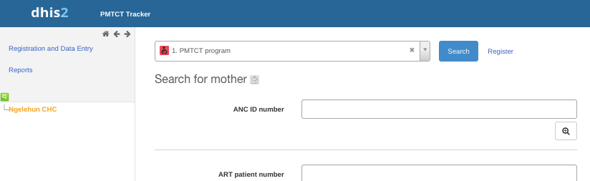

This will take you to the Tracker Reports portal, where four different types of reports are available. The most important one for our purposes is the Overdue Events report:
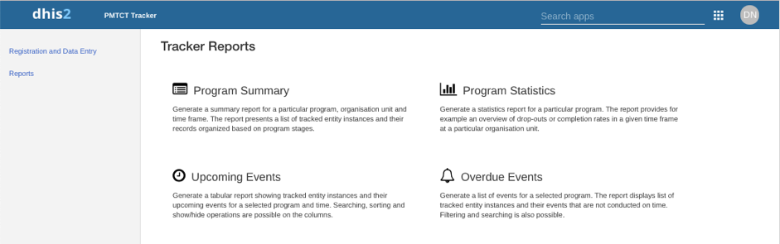
Clicking on “Overdue Events” will take you to the Overdue Events report for the PMTCT Program. The diagram that follows explains this report.
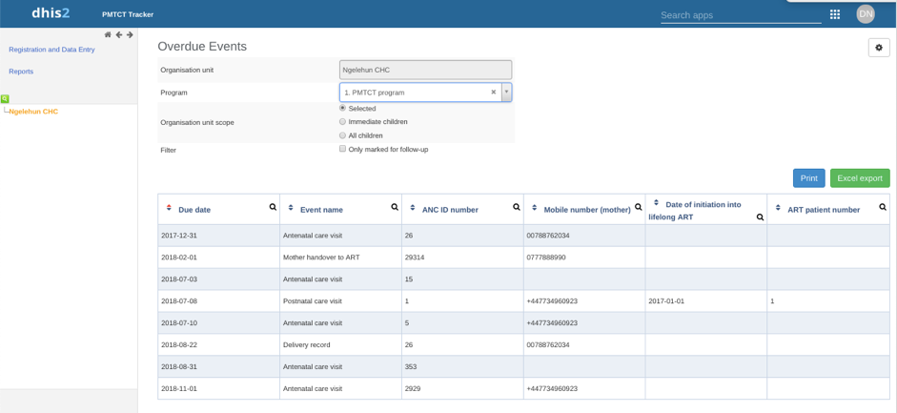
You can select the clinic or facility here. Supervisors will be able to see multiple clinics or facilities in their area and can chose any one of them.
This shows the date that the visit or delivery should have occurred—the most overdue and urgent events are shown at the top of the list.
Select the program here (PMTCT Program or Exposed Child Program). You will need to run the report separately for each program.
Clicking anywhere on a listing will open the Patient Dashboard for that patient, so you can easily view the patient’s history.

It is extremely important that you run these two Overdue Events reports at the start of each day (once for mothers and then once for children) and take immediate action to contact patients as necessary.
When following up with patients, please keep in mind that:
- The phone number shown for the child is usually the same as the one the mother provided for herself (it is automatically copied when the child is registered).
- You should talk only to the mother and not to any other family members—she may not have disclosed her HIV status to other family members.
- Some of the patients listed here may not have been to your clinic or facility for quite some time (for example, it may be six months since a child came for his or her previous DNA PCR test), so you will need to remind them of the overall pathway of care and why this visit is important.

8.2 How Automated Patient Notifications Work
Each night the PMTCT Tracker will automatically send a message to any patients who have provided a mobile phone number. These notifications are carefully worded to mention only general antenatal, postnatal, or child care visits, to prevent disclosure of the patient’s HIV status. (An SMS can be read by anyone with access to the phone.) The following notifications are sent:
- Upcoming ANC visit reminder: This is an SMS that is sent to every patient the day before an ANC booking, reminding her that she is due to come to the clinic or facility. Few countries book a specific time for a patient’s appointments, so this is worded as a general reminder:
This is a reminder that you have an antenatal care visit (pregnancy check-up) tomorrow at [clinic or facility name].
- Missed ANC visit reminder: This is an SMS that is sent to any patient who misses her ANC booking by more than seven days, asking her to attend as soon as possible:
You have missed your antenatal care visit (pregnancy check-up). Please attend [clinic or facility name] as soon as possible to have your check-up.
- Delivery details not recorded: This is an SMS that is sent to any patient who does not yet have details of her delivery recorded. It is sent seven days after the date of the delivery booking in the system (which is in turn two weeks after the expected due date). Because the patient is likely to have delivered, but at another clinic or facility, this reminder is worded in terms of “details not yet recorded” rather than “not yet delivered”:
We have not yet received details of the birth of your child. Please bring all papers you have been given to [this PMTCT clinic or facility name], where we can also provide postnatal care (follow-up care).
- Upcoming PNC visit reminder: This is an SMS that is sent to every patient the day before a PNC booking, reminding her that she is due to come to the clinic or facility. Few countries book a specific time for a patient’s appointments, so this is worded as a general reminder:
This is a reminder that you have a postnatal care visit tomorrow at [clinic or facility name].
- Missed PNC visit reminder: This is an SMS that is sent to any patient who misses her PNC booking by more than seven days, asking her to attend as soon as possible:
You have missed your postnatal care visit (follow-up care) on [date]. Please attend [clinic or facility name] as soon as possible.
- First missed DNA PCR test reminder: This is an SMS that is sent for any child who misses his or her DNA PCR test booking by more than seven days, asking the mother to attend as soon as possible:
You are overdue for a child health visit—please urgently bring your child to [clinic or facility name].
- Second missed DNA PCR test reminder: This is an additional SMS that is sent for any child who has still not attended 14 days after his or her DNA PCR test booking:
You are overdue for a child health visit—please urgently bring your child to [clinic or facility name].
It is important that you are aware of these notifications, but because they cannot be sent to all patients (not all patients will have mobile phones), you will also need to do your own personal follow-up on these patients. All patients who have been sent a reminder for a missed visit or delivery details not recorded will also appear in the list in the Overdue Events report (see Section 8.1), so you can actively monitor their follow-up.

9. PMTCT Dashboards

9.1 DHIS2 Dashboards
A DHIS2 dashboard is a collection of individual report items (tables, charts, maps, etc.) grouped around a theme or topic. Dashboards summarize the PMTCT data that you have captured over time and enable you to monitor how successfully you are managing your PMTCT Program, using the official PMTCT indicators. We have presented a dashboard with two official PMTCT indicators as examples:
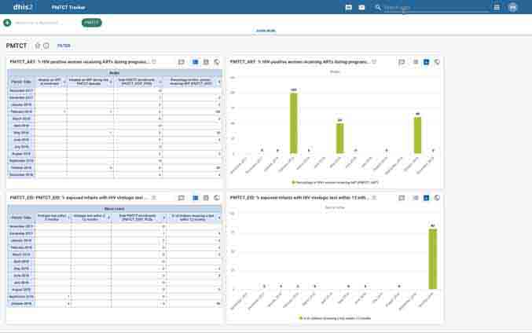
When using the DHIS2 dashboards, it is important to understand the following:
- For confidentiality reasons, a wide range of staff may have access to these dashboards without having access to the Tracker Capture module or the Patient Dashboard; this enables them to see the summarized data on the performance of PMTCT services without being able to see any individual patient data.
- Each dashboard is assigned to everyone (“public”) or to specific groups of users. For this reason, you may be able to view a dashboard that another user cannot see.
- The dashboards can show all clinics and facilities. Although you can only edit data for your own clinic or facility (or area of supervision), you will typically be able to view dashboards that cover all areas and facilities, enabling you to compare your own performance against others.
- Dashboards are usually only updated overnight, so any data capture you do today will not display until tomorrow. Monitoring and evaluation or health management information system staff can manually update the dashboards more frequently than that if necessary. Note that this is different from the Overdue Events reports that you use for tracking patients, which are updated in real time as data are captured.

9.2 PMTCT Indicators
When viewing dashboard reports containing PMTCT indicators, it is important to keep in mind that official PMTCT indicators are not based on tracking individual patients over time, but on activity in the given period. This means that the numbers often come from different cohorts of patients, giving percentages that are sometimes higher than 100 percent.

9.3 How to Open and Use the Dashboard Module
To open the Dashboard module, click on the “Search apps” drop-down option in the top right-hand corner of the screen and select the Dashboard icon:

When the Dashboard module opens, you will see each available dashboard as a green button—simply click on the green button to view that particular dashboard. If the dashboard does not fit on your screen, you may need to use the scroll bars to move right or down to see it all.
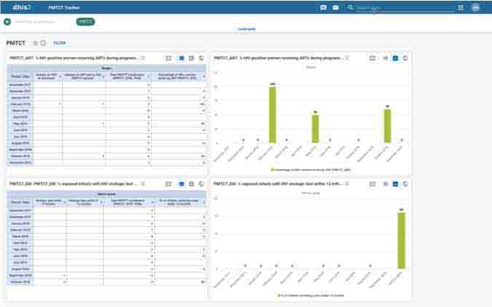

If you have the appropriate role (not all users will have this role), you can view detailed information on any individual item by clicking on the “explore” icon () next to the title, which will open a new page showing you that item on its own. You can then adjust the settings, such as the periods and layout, and click on “Update” to run a customized version of the report.



For an example of a local protocol, see the Uganda Ministry of Health National Guidelines for the Management of Common Conditions, Chapter 3. HIV/AIDS and Sexually Transmitted Infections: https://health.go.ug/sites/default/files/Uganda%20Clinical%20Guidelines%202016_FINAL.pdf.
The Browser Cache is how your computer “remembers” data downloaded from the Internet, so it does not have to keep downloading the same information. If you experience problems with unexpected responses from your computer, you can use the Browser Cache Cleaner to clear these data, which may resolve the problem.
Important note: The enrollment date and last menstrual period (LMP) date cannot be changed after you click on “Save and continue.” If you reach the Patient Dashboard and realize that either of these dates is wrong, you will need to delete the enrollment and create a new enrollment. You can do this from the Patient Dashboard by clicking on the red “Delete” button below the LMP date.
If you accidentally click on “Complete and exit,” return to the patient’s record and click on the relevant visit box. Click on the orange “Incomplete” button, which will open the visit record again. The orange button will now say “Complete.” Click on this button, and the pop-up message will appear again, allowing you to book the follow-up visit.
When first installing the PMTCT Tracker, this timeframe can be configured according to local requirements.

