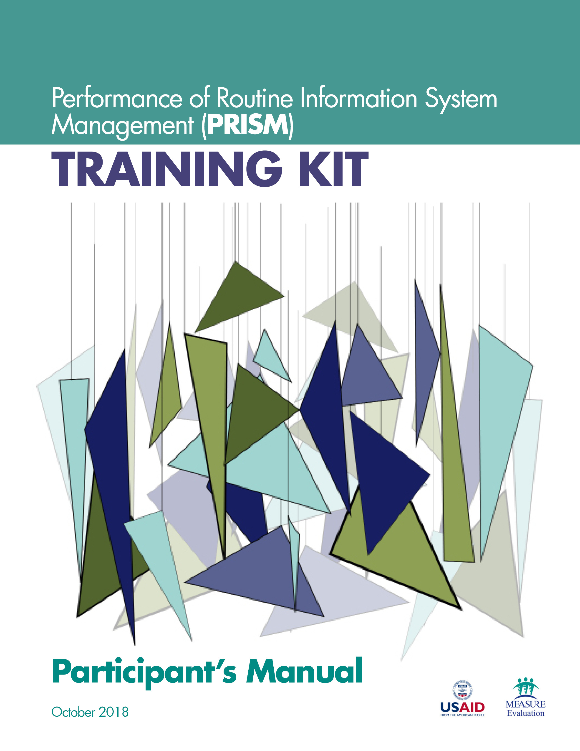
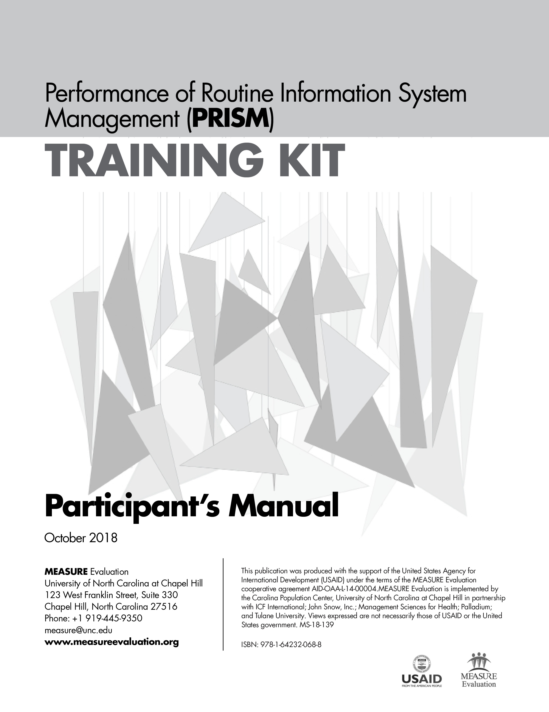

Acknowledgments

MEASURE Evaluation, funded by the United States Agency for International Development (USAID), thanks those who contributed to the updated version of the Performance of Routine Information System Management (PRISM) Series – a collection of tools and supporting materials. It builds on the 2011 version of PRISM, developed by Anwer Aqil, Dairiku Hozumi, and Theo Lippeveld, all then members of MEASURE Evaluation, John Snow, Inc. (JSI), in collaboration with Mounkaila Abdou, JSI, and Alan Johnston, Constella Futures (now Palladium). This updated version draws on best practices and lessons learned from the many countries that have implemented PRISM assessments, as well as the new routine health information system (RHIS) Rapid Assessment Tool, developed by MEASURE Evaluation (available here: https://www.
measureevaluation.org/resources/tools/rhis-rat/routine-health-information-system-rapid-assessment-tool).
First, we wish to acknowledge USAID for its support.
Second, we thank the 80-plus respondents who answered our call for feedback on the original tools. We received feedback from GEMNet-Health partners as well as RHIS professionals from Afghanistan, Bangladesh, Canada, Ethiopia, Ghana, India, Indonesia, Kenya, Lesotho, Liberia, Malawi, Mexico, Namibia, Nepal, Nigeria, Philippines, Senegal, South Africa, Thailand, Uganda, the United States, and Zimbabwe.
Third, we extend our appreciation to the PRISM technical working group (TWG), an internal project advisory group, for its work in updating the tools. Members of the PRISM TWG are Tariq Azim, Alimou Barry, Hiwot Belay, David Boone, Suzanne Cloutier, Marc Cunningham, Mike Edwards, Upama Khatri, Sergio Lins, Moussa Ly, Amanda Makulec, Imelda Moise, and Kolawole Oyediran, from MEASURE Evaluation, JSI; Tara Nutley, from MEASURE Evaluation, Palladium; Sam Wambugu, from MEASURE Evaluation, ICF; David Hotchkiss, from MEASURE Evaluation, Tulane University; Stephen Sapirie, from MEASURE Evaluation, Management Sciences for Health (MSH); and Hemali Kulatilaka, from MEASURE Evaluation, University of North Carolina at Chapel Hill (UNC).
Fourth, we recognize the core team at MEASURE Evaluation for leading the revision effort and for their contributions. Special thanks go to Hiwot Belay, Sergio Lins, Suzanne Cloutier, Tariq Azim, and Jeanne Chauffour of MEASURE Evaluation, JSI, for their extensive work in revising and finalizing the PRISM Series.
Finally, we thank MEASURE Evaluation’s knowledge management team for editorial and production services.

For any questions about the tools or implementing any part of the assessment, please contact:
measure@measureevaluation.org.

Suggested citation:
MEASURE Evaluation. (2018). Performance of Routine Information System Management (PRISM) Training Kit: Participant's Manual. Chapel Hill, NC, USA: MEASURE Evaluation, University of North Carolina.

contents

Abbreviations 7
Overview of the PRISM Series 8
What the 2018 PRISM Series Offers 9
Uses of the PRISM Tools 10
Introduction 11
Training Agenda 12
Glossary 14
Session 1. Training Content and Orientation 17
Session 2. Introduction to the Health Information System (HIS) 18
Session 3. Introduction to the Routine Health Information System (RHIS) 21
Session 4. Introduction to the PRISM Framework 23
Session 5. Measuring Data Quality 25
Session 6. Use of Information for Decision Making 28
Session 7. Overview of the PRISM Tools 30
Session 8. Assessment Implementation 33
Session 9. Assessment Analysis 36

Abbreviations
CBIS | community-based information system(s)
DCI | data collection instrument
DQA | data quality assurance
DQR | data quality review
DDU | data demand and use
DHIS | district health information system
DSS | decision support system
EMR | electronic medical record
EPI | expanded program of immunization
eRHIS | electronic routine health information system(s)
FMIS | financial management information system(s)
HIS | health information system(s)
HMIS | health management information system(s)
HRIS | human resource information system
ICT | information and communication technology
LMIS | logistics management information system(s)
LQAS | lot quality assurance sampling
MNCH | maternal, newborn, and child health
M&E | monitoring and evaluation
MAT | Management Assessment Tool
MOH | Ministry of Health
NHA | National Health Accounts
OBAT | Organizational and Behavioral Assessment Tool
OPD | outpatient department
PRISM | Performance of Routine Information System Management
Q&A | questions and answers
RDQA | routine data quality assessment
RHINO | Routine Health Information Network
RHIS | routine health information system(s)
SMART | specific, measurable, achievable, relevant, and time-bound
USAID | United States Agency for International Development
WHO | World Health Organization


Overview of the PRISM Series
Using data to make evidence-informed decisions is still weak in most low- and middle-income countries. Especially neglected are data produced by routine health information systems (RHIS). RHIS comprise data collected at public, private, and community-level health facilities and institutions. These data, gleaned from individual health records, records of services delivered, and records of health resources, give a granular, site-level picture of health status, health services, and health resources. Most are gathered by healthcare providers as they go about their work, by supervisors, and through routine health facility surveys.
When routine data are lacking, or are not used, the results can be lower-quality services, weak infection prevention and control responses, lack of skilled health workers available where they are needed, and weak supply chains for drugs and equipment. These factors contribute to poor health outcomes for people.
MEASURE Evaluation, which is funded by the United States Agency for International Development (USAID), has provided technical and financial assistance to strengthen RHIS for more than 15 years. We have contributed to best practices at the global level and to the strengthening of RHIS data collection, data quality, analysis, and use at the country level. One of the project’s mandates is to strengthen the collection, analysis, and use of these data for the delivery of high-quality health services.
MEASURE Evaluation developed the Performance of Routine Information System Management (PRISM) Framework and suite of tools in 2011 for global use in assessing the reliability and timeliness of an RHIS, in making evidence-based decisions, and in identifying gaps in an RHIS so they can be addressed and the system can be improved. The framework acknowledges the broader context in which RHIS operate. It also emphasizes the strengthening of RHIS performance through a system-based approach that sustains improvements in data quality and use. PRISM broadens the analysis of RHIS performance to cover three categories of determinants that affect performance:
- Behavioral determinants: The knowledge, skills, attitudes, values, and motivation of the people who collect, analyze, and use health data
- Technical determinants: The RHIS design, data collection forms, processes, systems, and methods
- Organizational determinants: Information culture, structure, resources, roles, and responsibilities of key contributors at each level of the health system

Figure 1. PRISM Framework
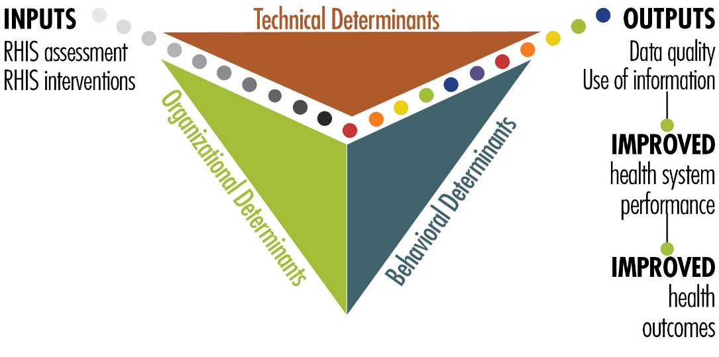

What the 2018 PRISM Series Offers
With USAID’s support, MEASURE Evaluation has revised the PRISM Tools and developed other elements, based on the PRISM Framework, to create a broad array of materials: the “PRISM Series.” It’s available on the MEASURE Evaluation website (https://www.measureevaluation.org/prism) and has the following components:
- PRISM Toolkit
- PRISM Tools (this is the fundamental manual of the PRISM Toolkit)
- PRISM Tools to Strengthen Community Health Information Systems
- Analysis Tool for Data from a PRISM Assessment
- PRISM User’s Kit (consisting of four guidance documents)
- Preparing and Conducting a PRISM Assessment
- Using SurveyCTO to Collect and Enter PRISM Assessment Data
- Analyzing Data from a PRISM Assessment
- Moving from Assessment to Action
- PRISM Training Kit
- Participant’s Manual (this document)
- Facilitator’s Manual
- 9 PowerPoint training modules

This new, more comprehensive PRISM Series is useful for designing, strengthening, and evaluating RHIS performance and developing a plan to put the results of a PRISM assessment into action.
The revised “PRISM Tools”—the PRISM Series’ core document—offers the following data collection instruments:
RHIS Overview Tool
This tool examines technical determinants, such as the structure and design of existing information systems in the health sector, information flows, and interaction of different information systems. It looks at the extent of RHIS fragmentation and redundancy and helps to initiate discussion of data integration and use.
Performance Diagnostic Tool
This tool determines the overall level of RHIS performance: the level of data quality and use of information. This tool also captures technical and organizational determinants, such as indicator definitions and reporting guidelines, the level of complexity of data collection tools and reporting forms, and the existence of data-quality assurance mechanisms, RHIS data use mechanisms, and supervision and feedback mechanisms.
Electronic RHIS Performance Assessment Tool
This tool examines the functionality and user-friendliness of the technology employed for generating, processing, analyzing, and using routine health data.
Management Assessment Tool
The Management Assessment Tool (MAT) is designed to take rapid stock of RHIS management practices and to support the development of action plans for better management.
Facility/Office Checklist
This checklist assesses the availability and status of resources needed for RHIS implementation at supervisory levels.
Organizational and Behavioral Assessment Tool
The Organizational and Behavioral Assessment Tool (OBAT) questionnaire identifies behavioral and organizational determinants, such as motivation, RHIS self-efficacy, task competence, problem-solving skills, and the organizational environment promoting a culture of information.

Uses of the PRISM Tools
These PRISM tools can be used together to gain an in-depth understanding of overall RHIS performance, to establish a baseline, and to rigorously evaluate the progress and effectiveness of RHIS strengthening interventions every five years, contributing to the national RHIS strategic planning process. Each PRISM tool can also be used separately for in-depth analysis of specific RHIS performance areas and issues.

Introduction

To support the use of the PRISM Tools, we have developed a curriculum of nine training sessions, which are outlined in this manual and supported by nine PowerPoint slide decks.
The training is conducted over three days (see the agenda, below). This manual also contains the following materials:
- Glossary
- Brief overview of each training session
- Group exercises
- Training evaluation form

Except for the glossary, abbreviations, and the training agenda, the materials are organized by session. Participants will be given paper copies of all presentations. Participants are encouraged to keep this manual as one of the main references for the PRISM assessment training.

Training Agenda
Performance of Routine Information System Management (PRISM) Assessment Training
Place: Date:
Page 1 of 2
Time | Topics
DAY 1
9:00: – 9:30 | Registration
9:30 – 10:30 | Opening of the training  - Welcome remarks  - Introductions (participants and facilitators)  - Participant expectations  - Session 1: Training Content and Orientation
10:30 – 11:00 | Tea break
11:00 – 12:00 | Session 2: Introduction to the Health Information System
12:00 – 12:30 | Session 3: Introduction to the Routine Health Information System
12:30 – 13:30 | Lunch
13:30 – 14:15 | Session 4: Introduction to the PRISM Framework
14:15 – 15:15 | Session 5: Measuring Data Quality
15:15 – 15:45 | Tea break
15:45 – 16:30 | Session 6: Use of Information for Decision Making
DAY 2
9:00 – 9:15 | Recap of DAY 1
9:15 – 10:30 | Session 7: Overview of the PRISM Tools (Introduction to the PRISM Tools and the RHIS Overview Tool)
10:30 – 11:00 | Tea break
11:00 – 12:30 | Session 7: Overview of the PRISM Tools (Performance Diagnostic Tool)
12:30 – 13:30 | Lunch
13:30 – 14:00 | Session 7: Overview of the PRISM Tools (Performance Diagnostic Tool, continued)
14:00 – 15:30 | Session 7: Overview of the PRISM Tools (eRHIS Performance Assessment Tool)
15:30 – 16:00 | Tea break
16:00 – 16:30 | Session 7: Overview of the PRISM Tools (Management Assessment Tool [MAT])
16:30 – 17:00 | Session 7: Overview of the PRISM Tools (Facility/Office Checklist)
DAY 3
9:00 – 9:15 | Recap of DAY 2
9:15 – 10:30 | Session 7: Overview of the PRISM Tools (Organizational and Behavioral Assessment Tool [OBAT])
10:30 – 11:00 | Tea break
11:00 – 11:45 | Session 7: Overview of the PRISM Tools (OBAT, continued)
11:45 – 13:00 | Session 8: Assessment Implementation
13:00 – 14:00 | Lunch
14:00 – 14:30 | Session 8: Assessment Implementation, continued
14:30 – 16:00 | Session 9: Assessment Analysis
16:00 – 16:30 | Tea break
16:30 – 17:00 | Q&A; closing




Glossary
Accuracy | In the context of data quality, accuracy means that the data transmitted from one level of the health system to another match e.g., data in client records at the facility level match data in the monthly health information system (HIS) summary report transmitted to the district level.
Activity | An activity is a defined action that is required as part of the implementation of a plan (also “task”).
Advocacy | Promoting a strategy or change to an organization’s leaders or policymakers, typically relating to a decision that is outside one’s own scope of control. Advocacy may involve other actors (in and/or outside the organization) to bring influence to bear on decision makers.
Behavioral determinants | In the context of the PRISM Framework, behavioral determinants are defined as those factors affecting HIS performance that are related to individual behavior, such as motivation, attitude, empowerment, and confidence.
Completeness | In the context of data quality, completeness means the degree to which HIS data (1) cover all geographical areas, services, and facilities; and (2) are filled out in full on data collection forms.
Confidence | Confidence describes how comfortable a person feels performing a certain task competently.
Culture of information | A culture of information refers to capacity and control to promote values and beliefs among members of an organization for the collection, analysis, and use of information to achieve an organization’s mission and goals.
Data | Data are an unprocessed set of values of qualitative or quantitative variables.
Data demand | In the context of the data demand and use (DDU) model, demand exists when a decision maker understands what kind of information is needed for a decision, and she or he proactively seeks out that information.
Data demand and use model | This model for understanding HIS performance examines the data use cycle, from demand for information to data collection and availability, to the use of information, and then to feedback, which in turn increases the demand for information.
Data quality | Data quality is the degree to which HIS data are accurate, timely, complete, and relevant.
Decision support system (DSS) | A DSS is a type of computerized information system designed to support decision making, with analytical reporting and trend analysis; characterized by a user-friendly graphic interface, with a connection to a data warehouse.
Evaluation | An evaluation is an assessment of whether a program’s objectives have been achieved.
Evidence-based (or evidence-informed) decision making | This refers to a management approach based on the use of reliable quantitative and qualitative information to guide decisions about the efficient targeting of resources.
Goal | A goal is a specific outcome to be accomplished to achieve a larger, overall result (e.g., to achieve an organizational mission).
Health information system (HIS) | A health information system is one that provides specific information support to the decision making process at each level of an organization.
Health system | The health system consists of all actors, institutions, and resources that undertake health actions (i.e., actions whose primary purpose is to promote, restore, or maintain health).
Indicator | An indicator refers to defined, measurable data indicating progress in the achievement of one or more objectives.
Information | Information is data that have been processed and interpreted so that they have meaning and can be used for decision making.
Information-generating process | This is a process by which HIS data are transformed into information that is used for decision making. The process includes the steps of defining information needs/indicators; data collection; data transmission; data processing; data analysis; and the management issues affecting this process (resources and organizational rules).
Monitoring | Monitoring is a continuous, systematic process of checking that implementation is proceeding according to a plan.
Objective | An objective is a specific outcome to be accomplished to achieve a goal. It may be a milestone along the way in the implementation of a strategy.
Organizational determinants | In the context of the PRISM Framework, organizational determinants are defined as those factors affecting HIS performance that are related to environmental or systemic issues, or the context in which the HIS functions. They could include resources, health system structure, roles and responsibilities of personnel, organizational culture, and budget control.
PRISM Framework | This is a model for understanding the technical, organizational, and behavioral factors that drive HIS performance. The framework helps HIS professionals with needs assessment, strategy planning, and improvement processes.
Proxy indicator | Indicator used to study a situation, phenomenon, or condition for which no direct information is available
Resource | A resource is the input needed to perform a task, such as funds, personnel, infrastructure, or materials.
Routine health information system (RHIS) | This refers to ongoing (for a period of less than one year) data collection on health status and behaviors, health interventions, and health resources.
RHIS performance | RHIS performance refers to the effectiveness of an RHIS, defined in terms of data quality and use of information.
Self-efficacy | This refers to a person’s judgments about their capabilities to organize and execute courses of action required to attain designated types of performance.
Stakeholder | A stakeholder is a person or organization affected in a significant way by the outcome of a process who can in turn affect the outcome of that process.
Strategy | A strategy is a method, set of activities, and/or process(es) required to achieve a goal.
Target | A target is a specific, measurable figure to be achieved for a given indicator, as part of a goal or objective (e.g., 90% on-time reporting rate).
Task | A task is a defined action that is required as part of the implementation of a plan (also “activity”).
Technical determinants | Technical determinants, in the context of the PRISM Framework, are factors affecting HIS performance that are related to system components, such as indicators, personnel training, technology, forms, data submission, and reporting.
Timeliness | Timeliness, in the context of data quality, means the degree to which HIS data are up-to-date and available when needed, and are submitted on time according to established deadlines.
Use of information | Use of information occurs when a decision maker is explicitly aware of a decision and alternatives, and considers relevant information in the process of making a decision.

Session 1. Training Content and Orientation

Learning Objectives
Participants will be able to express their expectations about the training; will be introduced to the training objectives, content, method, and agenda; and will discuss the proposed training rules.
Training Schedule

Session 2. Introduction to the Health Information System (HIS)

Learning Objectives
Participants will be able to define a health system and its generic functions, and to describe the relationship between the health system and both the HIS and RHIS.

Health System Functions and Goals

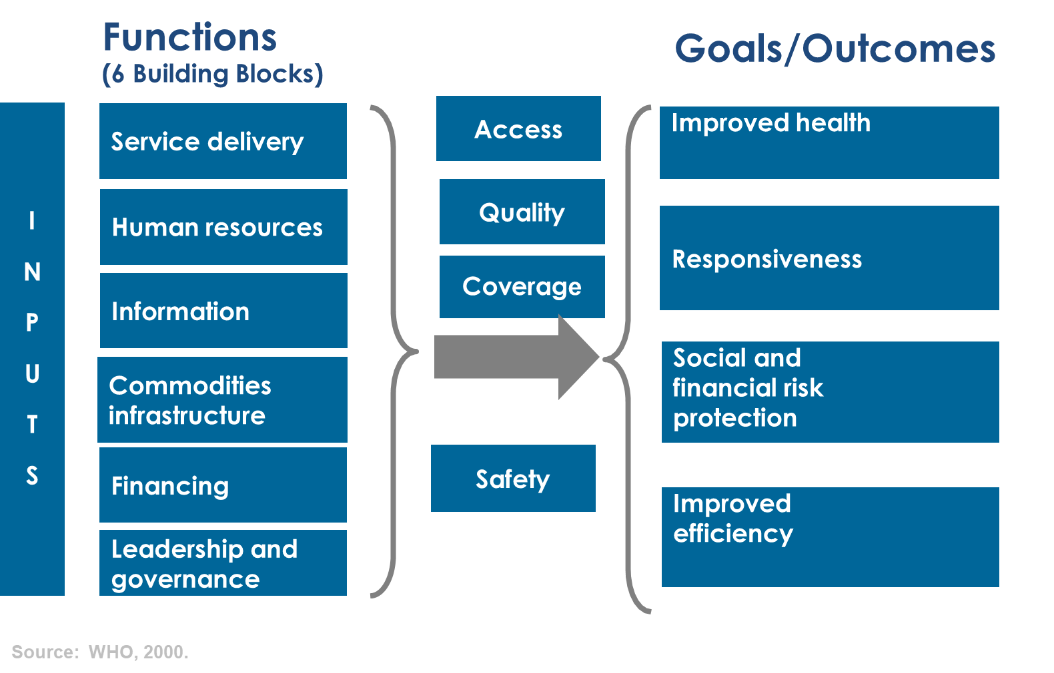
Source: World Health Organization, 2000
Health Information System (HIS)

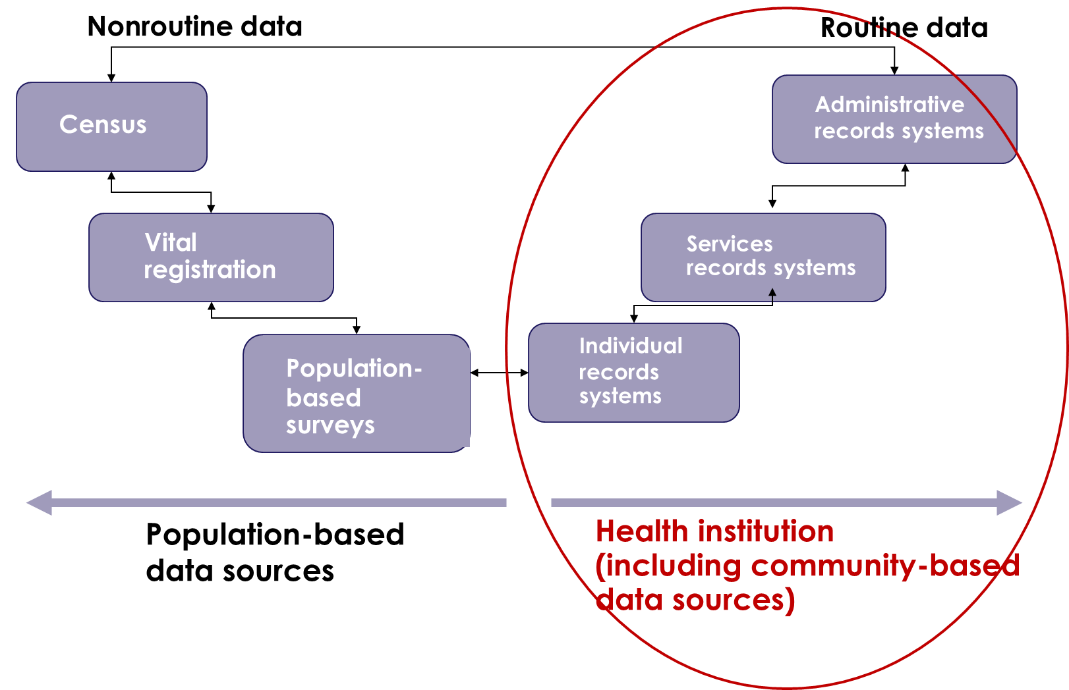
Source: Adapted from Health Metrics Network HMN) & World Health Organization (WHO). (2008). Framework and standards for country health information systems. Second edition. Retrieved from http://www.who.int/iris/handle/10665/43872

How does the HIS help to address health challenges?

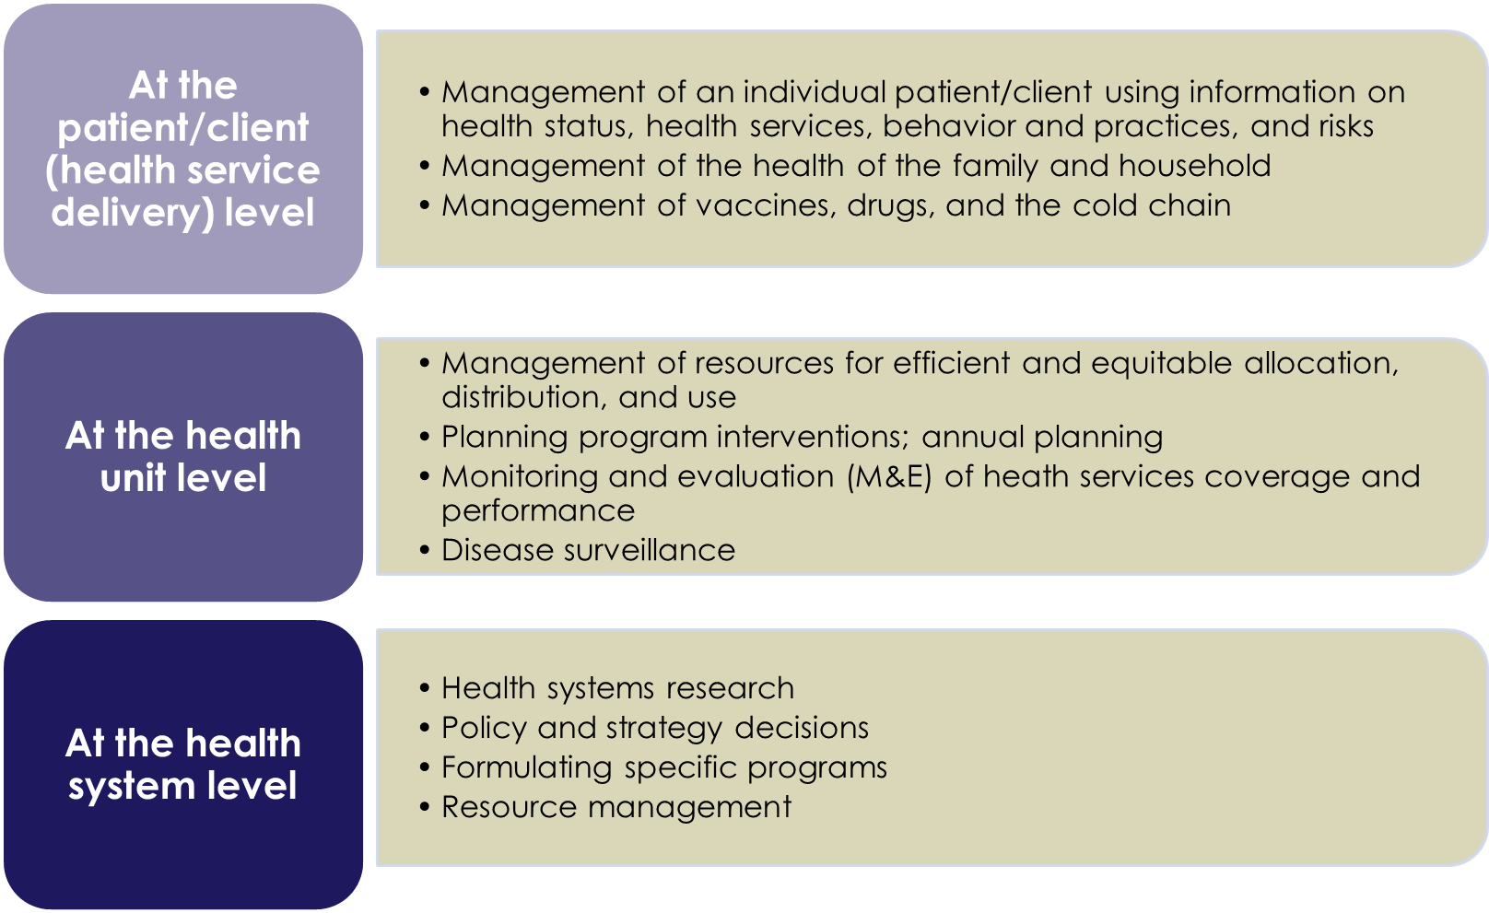

Group Work
- What are enablers and barriers of:
  - Assuring data quality?
  - Using HIS information?

Session 3. Introduction to the Routine Health Information System (RHIS)

Learning Objectives
Participants will be able to define the key data collection concepts; explain the roles of the RHIS in the health system management context; describe and appreciate the importance of the data management processes; describe the data management needs; understand the structure and processes for good data management; and identify and analyze possible constraints in the RHIS data management processes.

RHIS Data Management Processes

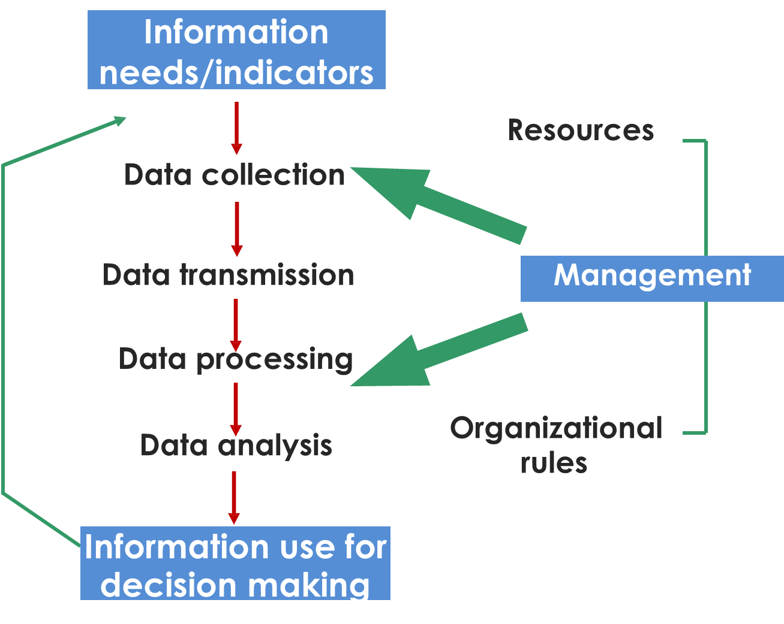

Use of Information for Decision-Making at All Levels
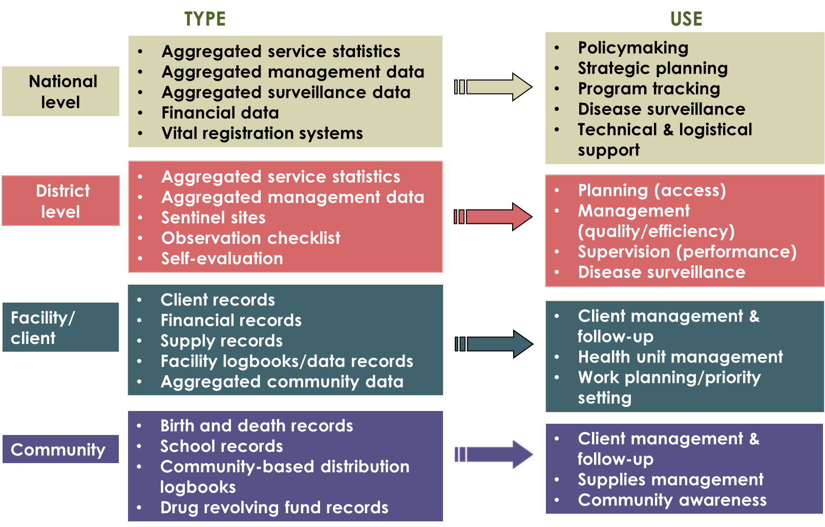

Session 4. Introduction to the PRISM Framework

Learning Objectives
Participants will be able to define “good” RHIS performance; demonstrate understanding of the three RHIS determinants; explain the components and uses of the PRISM Framework; identify the factors influencing RHIS performance; and describe the PRISM Conceptual Model.

PRISM Framework

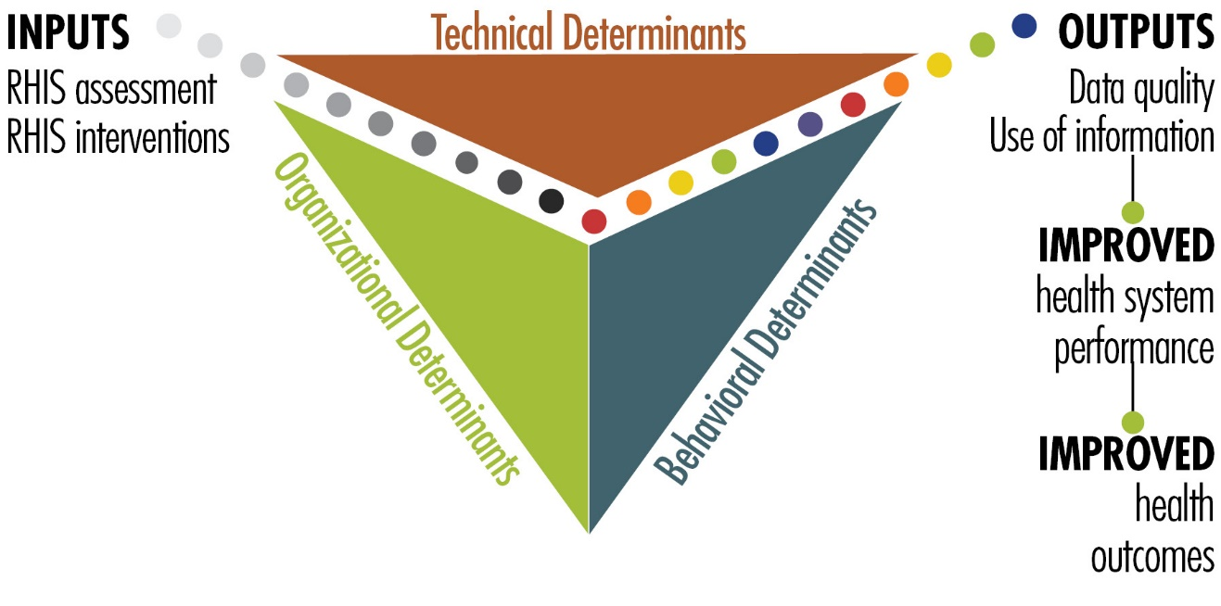
The PRISM Conceptual Model

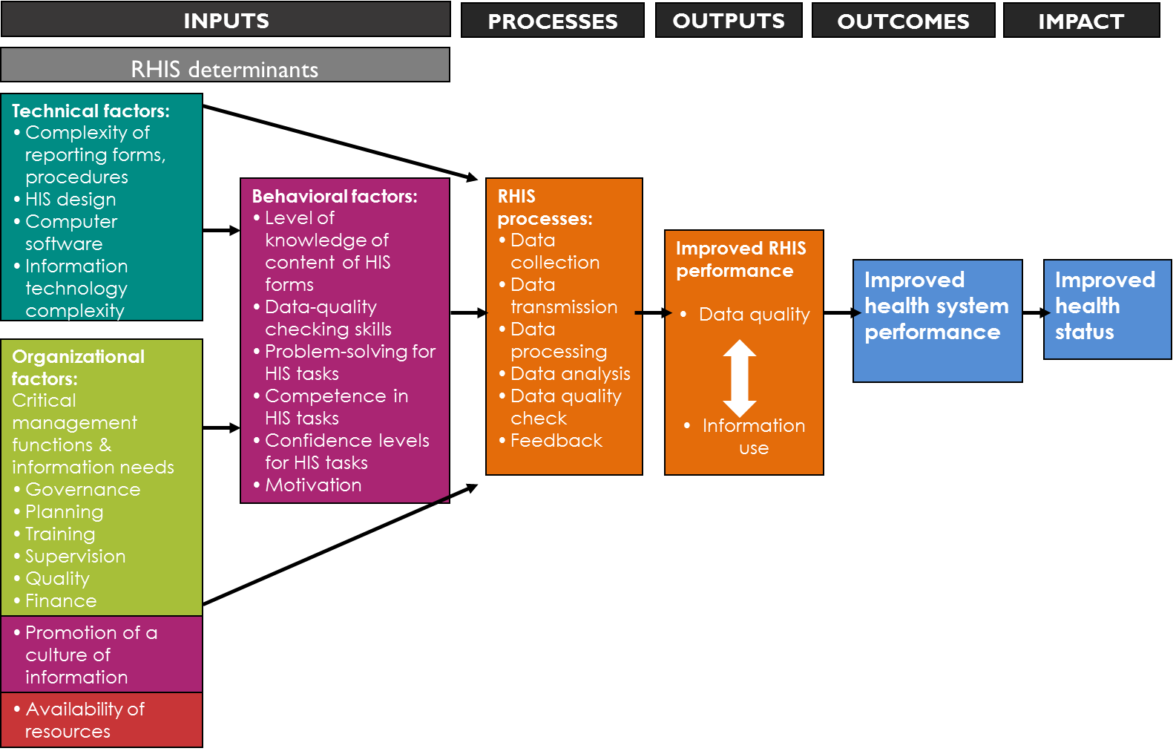

Session 5. Measuring Data Quality

Learning Objectives
Participants will be able to understand and explain the importance of and responsibilities for maintaining the quality of data across the different RHIS management levels; and to define the concept and dimensions of data quality, including the main data quality metrics.

Dimensions of Data Quality

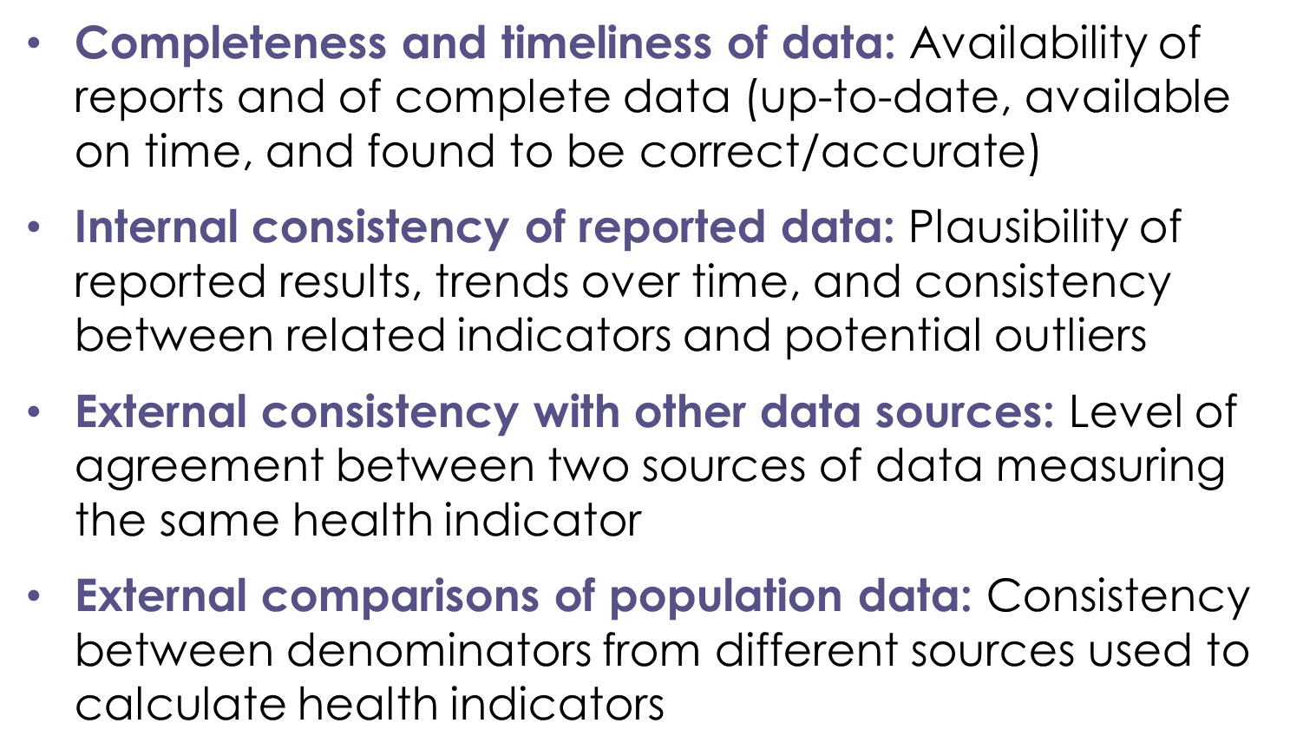

Completeness and Timeliness of Data

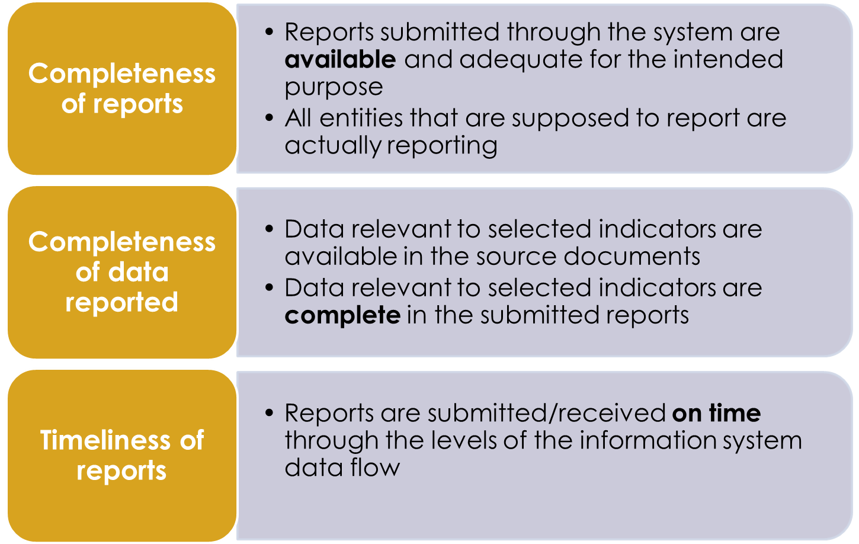

Core components of data quality

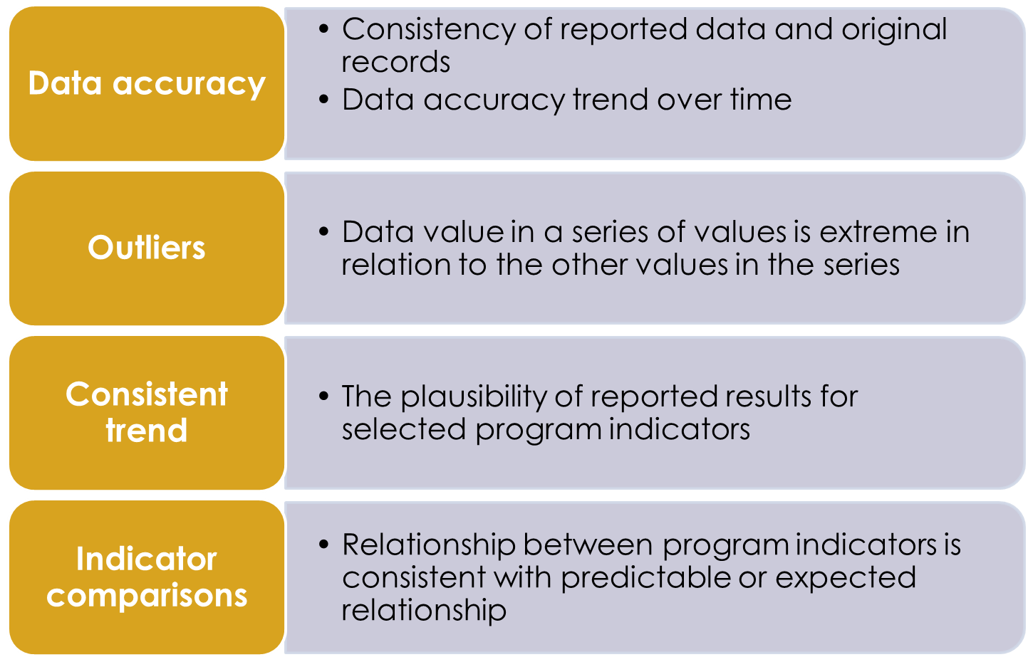

Session 6. Use of Information for Decision Making

Learning Objectives
Participants will be able to understand the importance of using data to inform program planning and policy development; appreciate how data use interventions can improve a HIS; understand and define data demand and use; and identify barriers to using data/information.

Data-Informed Decision Making Process

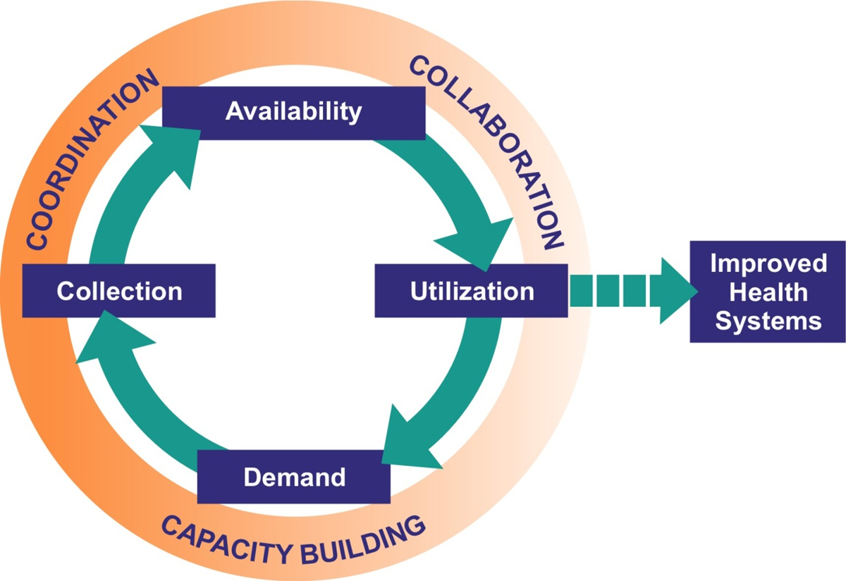

Source: Foreit, K., Moreland, S., & LaFond, A. (2011). Data demand and information use in the health sector: Strategies and tools. Version 2. Chapel Hill, NC, USA: MEASURE Evaluation: University of North Carolina. Retrieved from https://www.measureevaluation.org/resources/publications/ms-06-16b

What determines data demand and use?

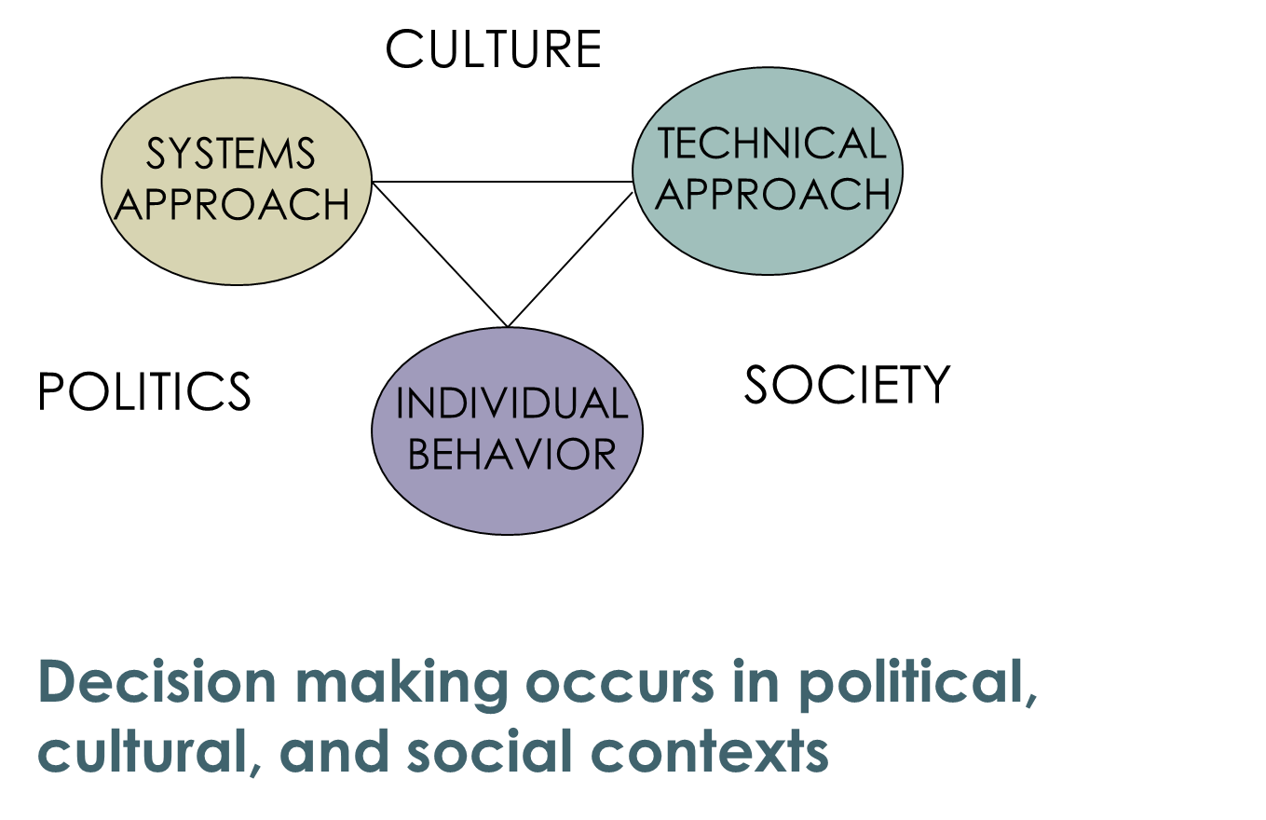

Session 7. Overview of the PRISM Tools

Learning Objectives
Participants will be introduced to the set of PRISM tools; will be able to explain the purpose of each tool; will be able to link each tool to the PRISM Framework; and will understand the application of the PRISM Tools to diagnose RHIS performance.

The PRISM Tools

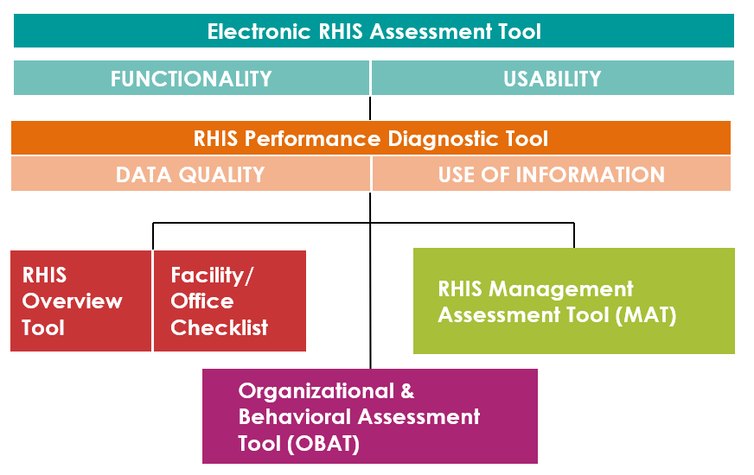

How PRISM Tools Are Related to the PRISM Conceptual Model

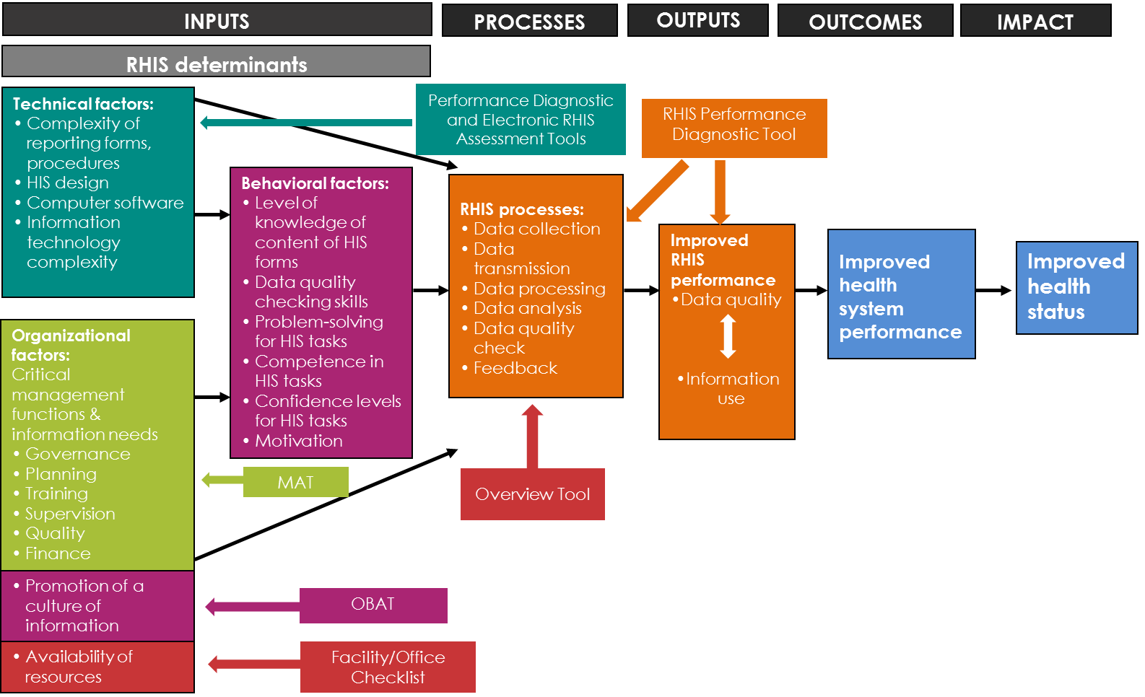

Application of the PRISM Tools

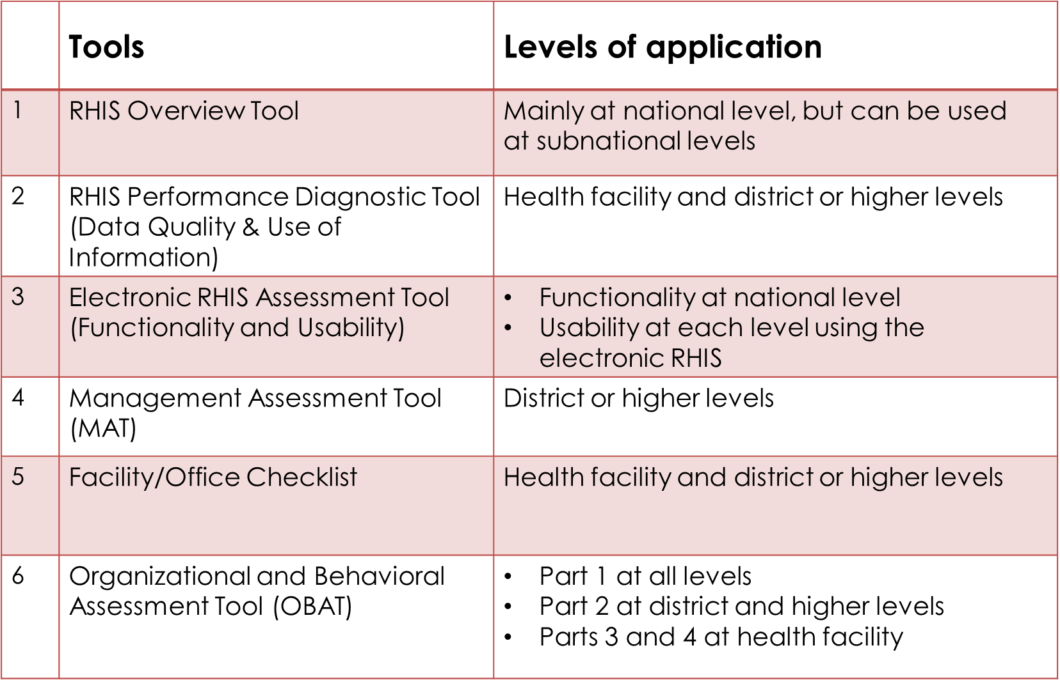

Session 8. Assessment Implementation

Learning Objectives
Participants will be able to describe the PRISM assessment implementation steps; understand the criteria for the adaptation of the PRISM Tools to the local context; understand the applied sampling method; and learn how to use such data collection/entry software application as SurveyCTO or any other software application designed for this purpose.

Steps to Administer PRISM Tools
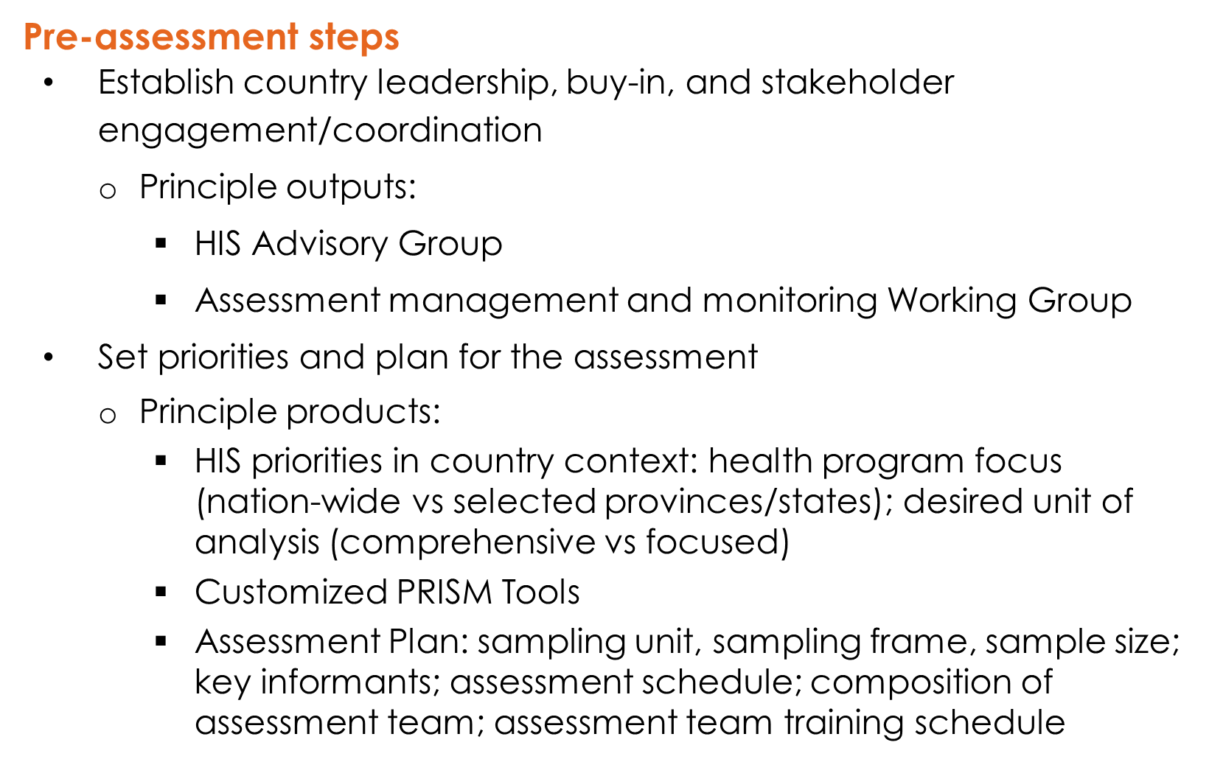

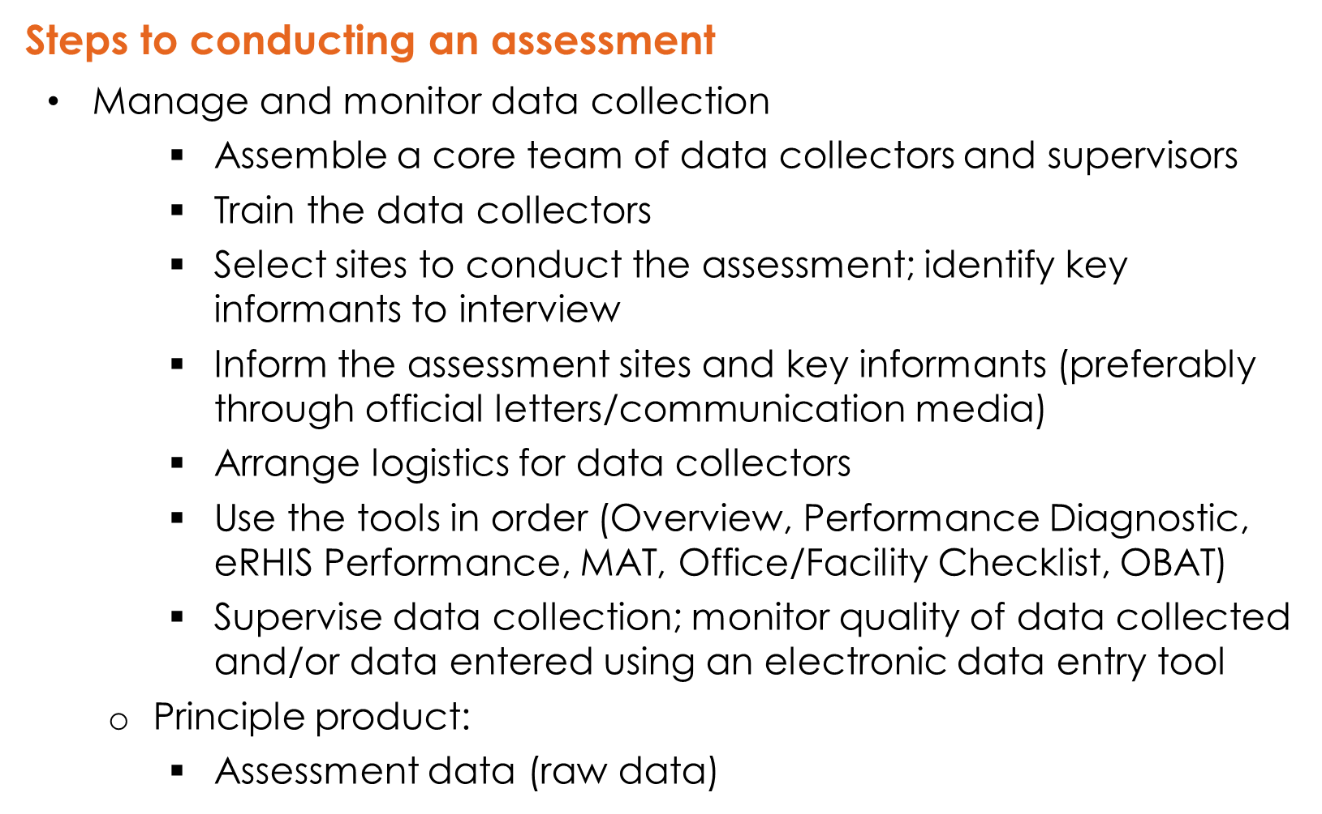
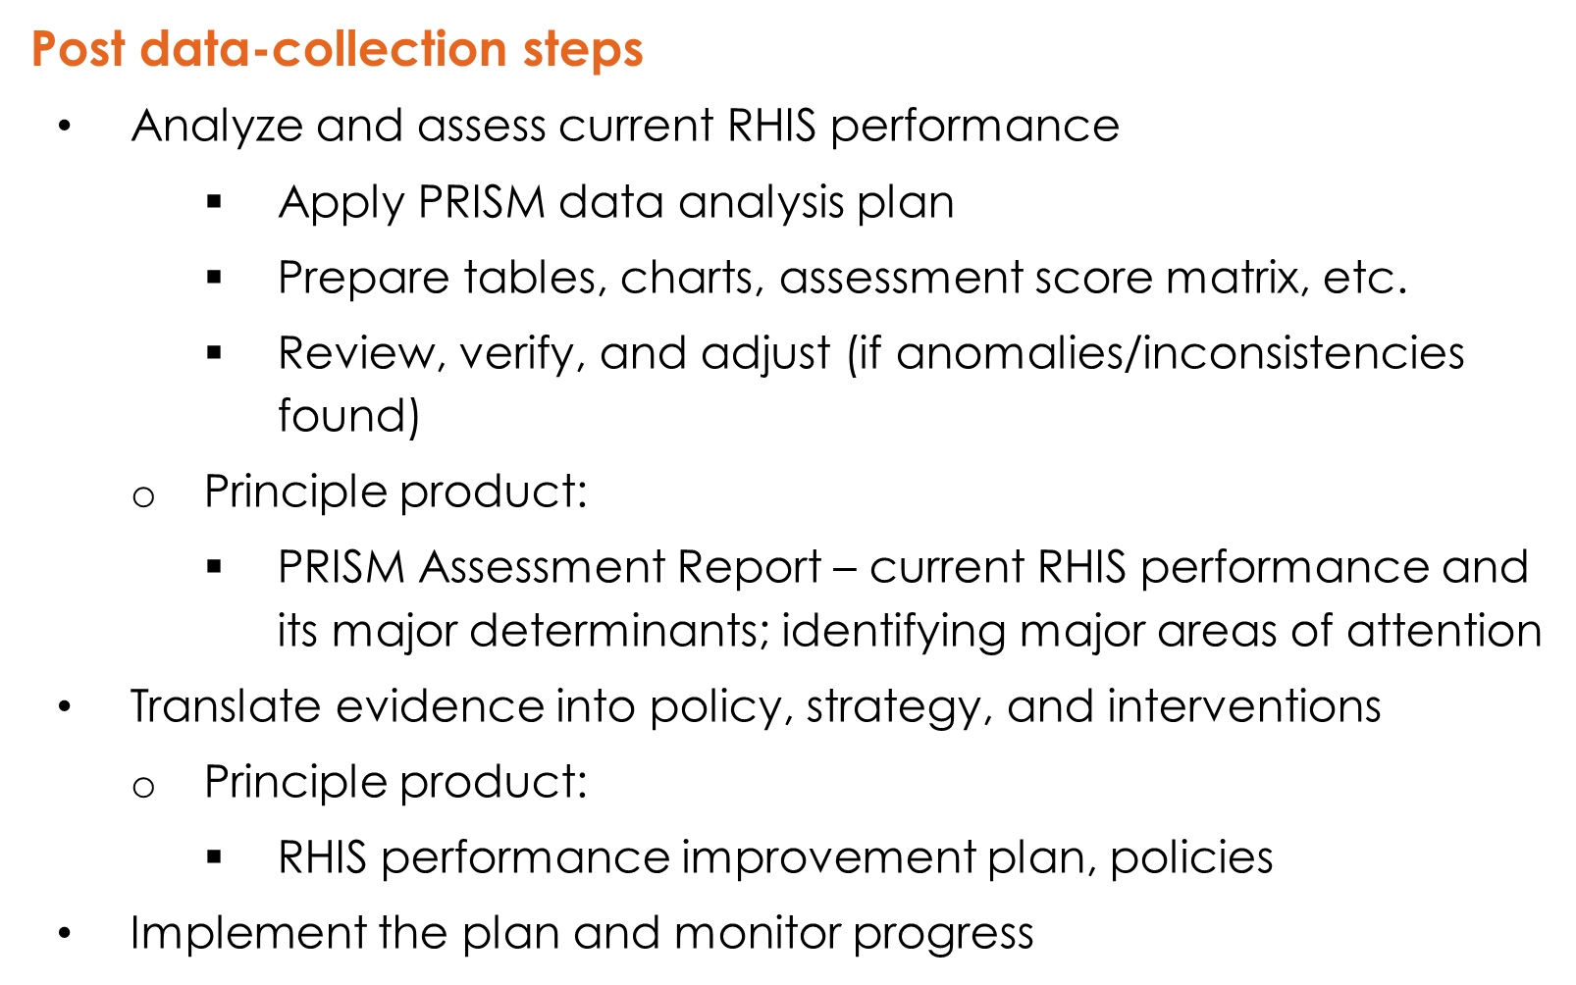

Session 9. Assessment Analysis

Learning Objectives

Participants will be able to explain how to analyze PRISM assessment data; describe examples of strengthening interventions based on PRISM assessment findings; and will also become familiar with the types of analyses performed in several countries.

Types of Analyses

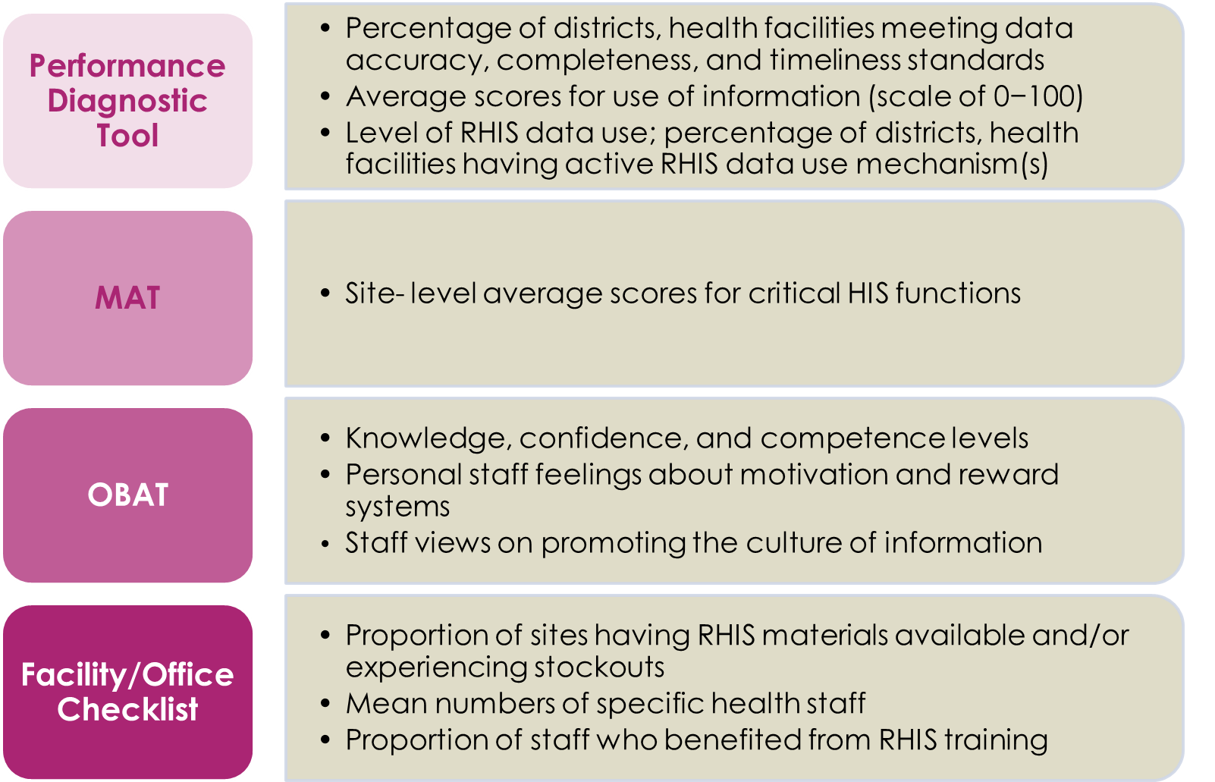

Overview of the PRISM Results

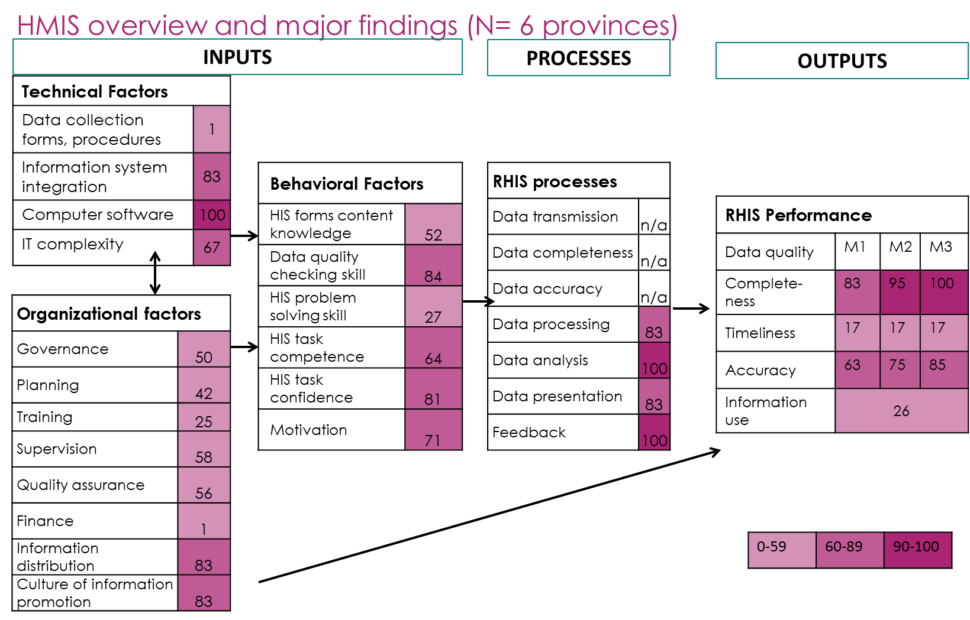


PRISM Training Evaluation Form

Place: Date:
For each training session listed below, please answer the following questions:
- How useful was the training session? Circle the response that best represents your opinion.
- Did the training session contain information that was new to you? Circle Yes or No.

Session |  | How useful was the training session? |  |  | New information?
2 | Introduction to the Health Information System | Not useful | Somewhat useful | Very useful | No | Yes
3 | Introduction to Routine Health Information System | Not useful | Somewhat useful | Very useful | No | Yes
4 | Introduction to the PRISM Framework | Not useful | Somewhat useful | Very useful | No | Yes
5 | Measuring Data Quality | Not useful | Somewhat useful | Very useful | No | Yes
6 | Use of Information for Decision Making | Not useful | Somewhat useful | Very useful | No | Yes
7 | Overview of the PRISM Tools | Not useful | Somewhat useful | Very useful | No | Yes
8 | Assessment Implementation | Not useful | Somewhat useful | Very useful | No | Yes
9 | Assessment Analysis | Not useful | Somewhat useful | Very useful | No | Yes

Comments or suggestions:
Page 1 of 2

Overall
How was the length of the training? | Too short | Just right | Too long
How would you rate the amount of information presented? | Too little | Just right | Too much
How would you rate the level of detail of the information presented? | Too little | Just right | Too much
How was the pace of training? | Too slow | Just right | Too fast
Was the content of the materials distributed adequate? | Too short | Just right | Too long
Were the sessions presented in a logical order? | No | Somewhat | Yes
Were the venue and training logistics satisfactory? | No | Somewhat | Yes
Were the facilitators knowledgeable? | No | Somewhat | Yes
Did the facilitators use effective training methods? | No | Somewhat | Yes
Were your expectations met? | No | Somewhat | Yes
Will you be able to apply what you learned in your work? | No | Yes | Not sure

Please provide any additional comments or suggestions regarding the training:
Page 2 of 2
Thank you for your feedback!





